**Empleya.Do. A DIGITAL HUMAN RESOURCE MANAGEMENT SYSTEM FOR EXPEDISE AGENCY AT LAZADA LOGISTICS SAN PEDRO LAGUNA**

A Thesis

Presented to the Faculty of

Computer Studies Department

College of Science

Technological University of the Philippines

Ayala Boulevard, Manila

by

Dem Charles R. Bule

Jeffree Allen Lingal

Christian L. Montero

John Albert Retiza

In Partial Fulfillment of the

Requirements for the Degree

Bachelor of Science in Information System

2024

**Chapter 2**

**CONCEPTUAL FRAMEWORK**

This chapter lays the groundwork for the development of Empleya.Do. A Digital Human Resource Management System for Expedise Agency at Lazada Logistics San Pedro Laguna. It contains a compilation of relevant literatures and studies related to the development of a Digital Human Resource Management System. The chapter also outlines the study’s conceptual model and define key terms for a clear understanding. This review provides a foundation to identify any gaps in existing knowledge.

**Review of Related Literature**

This study presents the key concepts and ideas relevant to the present study. It includes discussions on Web-based System, Web-Based-System Benefits, Web-Based Monitoring System, Online Recruitment, Inclusive – Talent – Management, Talent Management Benefits, Strategic Talent Management System, Human Resource Tools in Hiring Process, Generating Instant Feedback, Performance management System, Effectiveness of performance management system, Design and development of human resource management computer system, Unified Modeling Language, Wireframe, Hypertext Markup Language (HTML), Cascading Style Sheet (CSS), Javascript, React.js, Angular, PHP, Python, Node.js, MySQL, Laravel, Django, Express.js, Bootstrap, GitHub, Canva, Adobe XD, Figma, Visual Studio Code, and ISO25010.

***Web-Based-System***

According to Senthil.k-Wp. (2024), A web-based system is an application that is accessed via HTTP. The term web-based is usually used to describe applications that run in a web browser. It can, though, also be used to describe applications that have a very small component of the solution loaded on the client’s PC. The host server for a web-based system could be local, or it could be accessed via the internet.

The researchers proposed a web-based monitoring system because it is easy to access from both factory workers and human resource’ employees compared to traditional desktop apps that still need to be download.

***Web-Based-System Benefits***

In the article by Technologies, O. (2024), Web-based systems, also known as cloud-based or online software, have become increasingly popular in recent years. Unlike traditional software, which is installed on individual devices and can only be used on that device, web-based systems can be accessed 24/7 online using a web browser. This allows users to access the software from any location and device. In this article, it will explore some of the benefits of using web-based systems.

* 24/7 Accessibility: Web-based systems can be accessed round-the-clock as long as an internet connection is available. In the current environment, where remote accessibility is a benefit, web-based systems allow customers and employees to access the system outside regular working hours and locations.
* Cross-platform Compatibility: Web-based systems are designed to be compatible with multiple hardware and operating systems, with user interfaces that can adapt to the device in use. User data is stored on remote cloud-based servers, which can be accessed anytime. On the other hand, traditional software typically does not support multiple operating systems. It may have specific system requirements for installation, with data storage limited to individual PCs.
* Scalability: Web-based systems can easily adapt to changing business requirements. This allows organizations to quickly scale up or down as their needs change without investing in new hardware or software. Traditional software systems need to roll out the upgrades to each user. The user has to install the upgrade on all the required PCs, which may incur more costs and require more installation time.
* Additional Security Layers: Web-based software stores data on servers with multiple layers of security and is automatically updated with the latest security patches and antivirus upgrades. This provides a higher level of protection compared to traditional software.
* Minimal Disruption: Web-based systems undergo upgrades and maintenance at the server level, minimizing disruption to end users.
* Collaborative: Web-based systems allow team members to collaborate and manage system information in real time, regardless of the location. Many web-based applications also facilitate version control, allowing users to easily track changes.
* Increased Productivity: Web systems may offer automated processes that help in delivering quantifiable business benefits over traditional desktop software. Centralized data storage can also enhance productivity and efficiency by allowing users to easily access and share data.

***Web-Based Monitoring System***

   According to Mleke & Dida (2020), Web Based Monitoring and evaluation systems are used by organizations or governments to measure, track progress, and evaluate the outcomes of projects. Organizations can improve their performance, effectiveness, and achieve results in project success by strengthening their monitoring and evaluation systems. Moreover, various studies reveal the need for information and communication technology systems in monitoring and evaluation activities.

***Online Recruitment***

According to A, E. T. J. (2021). E -recruitment, also known as online recruitment, is the practice of utilizing technology and in particular web-based means for tasks which involves finding, attracting, assessing, interviewing and hiring new personnel. It is intended to make the process involved more efficient and effective, as well as less costly. Online recruitment can reach a larger pool of potential employees and facilitate the selection process. She pointed out that the Effectiveness of the Internet as a Recruitment Source, the author stipulated that the internet as a recruitment source is an effective tool to use in reaching target markets when compared to more traditional recruitment sources.

Based on the study by Fachrizal, M. R., Radliya, N. R., & Manik, A. (2019), e-recruitment is an electronic-based system that significantly enhances the effectiveness of the Human Resource Department. The increasing number of applicants in many organizations and companies complicates the management of applicant data, resulting in a prolonged recruitment process and the potential hiring of employees who do not meet the desired competencies. By designing and implementing an e-recruitment system, these issues can be mitigated. The use of a profile matching method within the system further aids in selecting applicants who best fit the company's requirements.

In addition to Sima, V., Gheorghe, I. G., Subić, J., & Nancu, D. (2020). Online recruitment platforms allow better matching between the needs of the employers and the skills of the applicants to find suitable people for certain managerial functions. IT’s influences on communication are also generating implications for marketing managers dealing with increasingly demanded consumers in today’s digital environment.

***Inclusive – Talent – Management***

In a Study of Kaliannan, Darmanlinggam, and Doromsamy (2024) they pointed out the growing value of Inclusive Talent Development (ITD) within Talent Management Systems (TMS) they Highlight that Inclusive Talent Development (ITD) is a Crucial for the skill, talent growth and Organizational performance. IDT practices lead to Competitive advantage, particularly when analyzed through the Resource-Based View and VRIO model. Thus, the approach focuses on developing all employees, not just top or elite talent, thereby reducing skills mismatched and enhancing overall organizational capabilities.

***Talent Management Benefits***

In Study of Li Qi, Voon, and Jia Qi, (2021) on their examination in Government – Linked Companies or GLCs in Malaysia, they make point of the impact of Talent Management through employees engagement levels, highlighting various challenges such as bureaucratic interference, ineffective performance management systems(PMS), Talent retention obstacle, and talent shortages, *with proposed strategic intervention to address these issue and elevate employee engagement, fostering organizational growth and their performance.*

* To state these challenges, Li Qi, Voon and Jia Qi, Cheong Provide and Recommend Strategic Interventions for GLCs in Malaysia
* Establishing Clear Authority and Hierarchical Management: They proposed a defined management system to mitigate bureaucratic interference, following the Bureaucracy Theory of Mac’s Weber.
* Fair Performance Management System: Li Qi Voon, and Jia Qi Ensure Fairness in PMS to pin out inefficiencies and promote equity in evaluation and compensation.
* Understanding Workforce Needed: they enhance Maslow hierarchy of needs to identify and meet employee needs, thereby enhancing job satisfaction and retaining qualified talents
* Retaining and Acquiring the Right Talent: They Employed the Model 4B’s to minimize talent inefficiencies by acquiring suitable or capable talent and ensuring their commitment.To their roles

***Strategic Talent Management System***

Based on Chen, Lee, and Ahlstrom (2019), The Strategic Talent Management System is a critical situation for developing and retaining talent, which helps organizations or a company compete effectively. By focusing investment on a talented group, STMS align employees’ job interpretation in terms of employee calling. This approach fosters excellence in employee behaviors such as entrepreneurship and voice, which enhances organizational performance.Study shows or provides observational evidence that worker calling acts as a key mediator in developing these beneficial work behaviors, Picturing the importance of STMS in improving or refined talent management strategies and build a competitive edge for organizations.

***Human Resource Tools in Hiring Process***

According to Boiko, Volianska-Savchuk, Bazaliyska, and Zelena Published in (2021) 11th International Conference on Advanced Computer Information Technologies (ACIT) They emphasize the Crucial role of modernized HR equipment or tools in enhancing the HR Hiring process. The study shows the necessity of employing recruitment services and proposes a scheme to improve recruitment practices through the system of smart recruiting methodologies. By applying advanced and modernized HR tools, the authors establish criteria for choosing the candidate search sources and develop a comprehensive set of specific skill sets required for HR positions within organizations. Particularly, the introduction of a smart recruitment evaluation system enables the ranking of candidates based on a calculation of the ratio between alternative and ideal HR criteria, using multi criterion competent analysis. This emphasis on leveraging advanced HR tools underscores their potential in facilitating more efficient and effective recruitment practices, contributing to centralized hiring processes and improved organizational results.

***Generating Instant Feedback***

According to Jia, Qinjin et al. (2022), timely feedback is critical for academic success, yet traditional methods often fall short due to resource limitations. To address this, automated feedback systems have emerged, spanning various educational tasks. However, research on automated feedback for student project reports remains limited. In their study, Jia, Qinjin et al. introduce "Insta-Reviewer," a data-driven system utilizing advanced natural language processing (NLP) models to provide instant feedback on project reports. Their research demonstrates near-human performance in generating feedback, highlighting the potential of automated systems to enhance learning outcomes.

***Performance management System***

Based on Vainieri, M., Noto, G., Ferre, F., & Rosella, L. C. (2020) Consistently practice all elements and measure the performance management system. Through a survey approach the study evaluated how well administrators and faculty members adhere to the performance management system. The results indicate that the institution has incorporated all components of a performance management system, such as planning, monitoring, evaluation, It is found that the institution's performance management system is effective and aligns with the belief that measuring leads to action, managing leads to improvement and rewarding leads to prompt action.

In addition to Minoza J. (2024). Research studies have highlighted the importance of performance management as a factor for organizational success. Within the hospitality industry performance management plays a role in motivating and empowering employees to provide services. According to Williams Principle of Performance Management measuring tasks ensures completion managing tasks leads to outcomes and rewarding tasks results in completion (Williams, n.d.). The findings indicate that the institution has successfully implemented also a components that was mentioned early on that a performance management system is capable when it comes on creating a plan, monitoring, evaluation, development and recognition of performance.

***Effectiveness of performance management system***

Based on Awan, S. H., Habib, N., Akhtar, C. S., & Naveed, S. (2020). A comprehensive performance management system is used by organizations to measure, track progress, and evaluate the effectiveness of employee performance; the mediating effect of work engagement was also examined. Organizations can improve their performance, effectiveness, and achieve results in employee success by strengthening their performance management systems. Moreover, various studies reveal the need for a comprehensive performance management system in order to enhance employee work engagement and task/contextual performance.

In addition to Maseke, B. F., Unengu, V. K., & Haufiku, T. (2022) Employees strongly believe that performance counseling should be introduced in the organization. Furthermore, organization must provide training to employees on managing work balance stress. In addition, employees find it difficult to achieve their goals because no clear career path is provided. Performance feedback needs to be introduced in the organization to identify areas of weakness and strength and offer training where it is necessary.

***Design and development of human resource management computer system***

Based on Wang, T., Li, N., & Li, H. (2021) The design and development of this system aims to provide technical support for the service quality of enterprise human resource management business, to improve the overall efficiency, promote the pace of enterprise strategic development, and enhance the market competitiveness of enterprises. this system can be used by users without geographical restrictions and system maintenance. In this system, performance logic and business logic are separated, which makes it convenient for the development and maintenance of the system. The system mainly includes six modules: personnel management, organizational management, recruitment management, training management, salary management and system management, which integrates enterprise information and realizes the functions of easy access and easy query of information databases.

*Understanding the system six module of Wang, T., Li, N., & Li, H. (2021)*

* *Personnel management* -  is used to input, query, add, modify and delete all the information of enterprise staff from entering the duty to exiting the duty.
* *Organizational management* - is a comprehensive management of enterprise architecture and job information, including comprehensive information of various departments, existing positions and vacant positions, so that enterprises can adjust and deploy relevant departments and positions in a timely manner in the development process.
* *Recruitment management* - is the most basic part of HRMS, which is mainly used to track and record the recruitment process of new employees, including recruitment content promotion, resume reception, appointment interview and entry approval.

In Addition to Pathinayake, Y. (2021) in Online Recruitment Management System, This system enables advertise vacancies via the website, client companies can send vacancy details to advertise, job seekers can apply for vacancies, schedule selection tests and interviews, held online selection tests, email notifications, report generation, get backups and restore backups. Using the Recruitment Management System the company can achieve the following benefits. Benefits of the system are reducing advertising costs, minimizing documentation, improving efficiency and productivity, reducing human error and saving time.

* *Training managemen*t - is an important part of HRMS, which is mainly used to track the whole process of enterprise training, including training plan, training implementation, training feedback and opinions.
* *Salary management* - is mainly used for the accounting, recording and managing of wages and insurance of employees. It includes compensation accounting and management, wage data records, employee tax and social security cost accounting, welfare payment schedule records and open query permissions of employees

***Unified Modeling Language***

According to Sheldon, R. (2023). Unified Modeling Language (UML) is a standard notation for modeling real-world objects as a first step in designing an object-oriented system. Its notation is derived from and unifies the notations of three object-oriented design and analysis methodologies:

* Grady Booch's methodology for describing a set of objects and their relationships.
* James Rumbaugh's object-modeling technique for modeling and designing software.
* Ivar Jacobson's object-oriented software engineering and its use case modeling.

The author stated that in 1994, Booch, Rumbaugh and Jacobson joined forces under the sponsorship of Rational Software, where they launched the original UML project. Soon, they were joined by others, and together, they integrated the three core methodologies, while also incorporating ideas from other sources. The author added that in 1997, Object Management Group (OMG) adopted the UML standard and published version 1.1 in December of that year. OMG is also home to other notable standards, including Business Process Management Plus, Common Object Request Broker Architecture, MetaObject Facility and Information Exchange Framework. Moreover, the author say that in 2005, UML was accepted by the International Organization for Standardization as an official ISO standard, and it is now widely embraced by the technology community. The most recent release of the UML standard is version 2.5.1, which OMG published in December 2017.

One of the purposes of UML was to provide the development community with a stable and common design language that could be used to develop and build computer applications. UML brought forth a unified standard modeling notation that IT professionals had been wanting for years. Using UML, IT professionals could now read and disseminate system structure and design plans -- just as construction workers have been doing for years with blueprints of buildings. It is now the twenty-first century and UML has gained traction in our profession. On 75 percent of the resumes I see, there is a bullet point claiming knowledge of UML. However, after speaking with a majority of these job candidates, it becomes clear that they do not truly know UML. Typically, they are either using it as a buzz word, or they have had a sliver of exposure to UML. This lack of understanding inspired me to write this quick introduction to UML, focused on the basic diagrams used in visual modeling. When you are finished reading you will not have enough knowledge to put UML on your resume, but you will have a starting point for digging more deeply into the language (Bell, D. 2023).

A picture is worth a thousand words, this idiom absolutely fits describing UML. Object-oriented concepts were introduced much earlier than UML. At that point in time, there were no standard methodologies to organize and consolidate object-oriented development. It was then that UML came into the picture. There are a number of goals for developing UML but the most important is to define some general-purpose modeling language, which all modelers can use and it also needs to be made simple to understand and use. UML diagrams are not only made for developers but also for business users, common people, and anybody interested to understand the system. The system can be a software or non-software system. Thus it must be clear that UML is not a development method rather it accompanies with processes to make it a successful system. In conclusion, the goal of UML can be defined as a simple modeling mechanism to model all possible practical systems in today’s complex environment (Mahara, N. 2020).

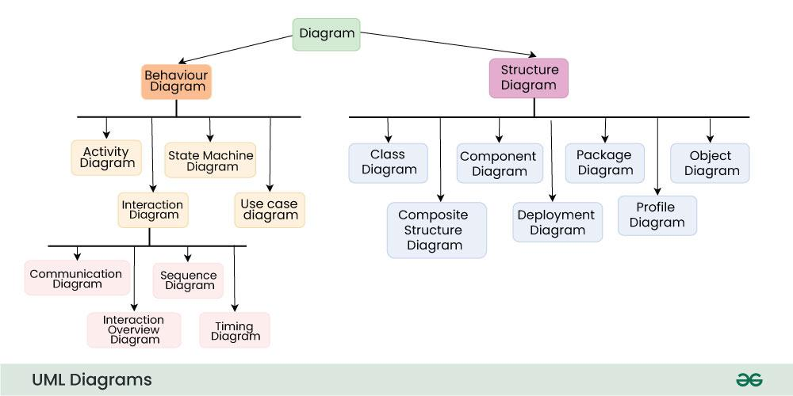

**Figure 1.** Unified Modeling Language

Source: https://tinyurl.com/3w7bafvh

***Wireframe***

According to Hannah, J. (2024). Wireframes are visual representations of a web page or app interface, stripped down to its bare bones. She stated that we should think of it as the architectural blueprint of your design project. They outline the structure and functionality of your product without getting caught up in colors, visuals, or specific content. Wireframes provide a clear overview of the page structure, layout, information architecture, user flow, functionality, and intended behaviors. Styling, color, graphics, and other design elements are kept to a minimum. They can be drawn by hand or created digitally, depending on how much detail is required. Wireframing is a practice most commonly used by UX designers. This process allows all stakeholders to agree on where the information will be placed before the developers build the interface out with code.

Based on the website of Balsamiq (2024). The primary reason for wireframing is to generate and communicate ideas, so making wireframes is not limited to any single role or specialization in an organization.

According to him, here are some roles that commonly make and use wireframes:

* Founders and Business Owners use them to communicate or pitch their product or app ideas to investors or product teams.
* Product Managers and Business Analysts use wireframes to translate requirements into visual specifications for designers or developers.
* UX Designers use them to explore and refine concepts before moving to high fidelity.
* Developers use them to sketch out user interfaces when they don't have a designer or when working directly with clients.
* Marketers and Copywriters use wireframes to explore landing page concepts and visualize the placement and size of copy on the page.

Moreover, the author stated that the purpose of a wireframe is to define a skeletal layout that is easy to understand, and encourages iteration and feedback. Getting to agreement on a good interface structure is a critical part of the software design process. Wireframes are important because doing this work now, before any code is written and before the visual design is finalized, will save you lots of time and painful adjustment work later.

In addition to Hanak, A. (2023), there are several reasons why wireframing improves the web design process. Although the wireframing step requires an initial investment of time and effort, it enhances the overall website design process in multiple ways. To begin with, a wireframe helps all parties involved visualize the website. It translates abstract ideas into tangible visuals, displaying the complete site architecture. This allows everyone on the web design project to communicate their opinions and ensure alignment. They can approve or disapprove the wireframe, enabling designers to make necessary adjustments. Moreover, wireframing clarifies website features before designers begin building them. Instead of relying on confusing technical jargon to explain the website's features and functionalities, wireframes present them visually and clearly, helping everyone understand their purpose and how they fit together in the final project. Additionally, wireframes keep the project focused on user experience. A well-designed user interface enhances user experience, leading to higher conversions, while a poorly designed UX results in high bounce rates. Wireframes help avoid such issues by prioritizing user experience from the start. Prototypes based on wireframes are tested with real users to gather valuable feedback, identifying and fixing design flaws early on. This ensures a user-focused website that meets the needs and expectations of its target audience. Furthermore, wireframing makes changes easier to implement. By identifying design flaws early, such as poor navigation, corrections can be made before significant time and effort are invested in full page design. This process is quicker and less time-consuming than making adjustments later. Besides, wireframes help refine navigation. They allow designers to visualize the user journey and test website navigation. By observing how easily users can locate content and pages, potential navigational issues, such as confusing dropdown menus or vague calls-to-action, can be identified and resolved.

Moreover, wireframing saves time throughout the project development process. A clear wireframe ensures the design team understands what needs to be built to meet specific goals, reducing the time spent on redesigns later on due to early feedback and adjustments. Finally, wireframing helps save money in the long run. By addressing design flaws and usability issues early, it minimizes costly revisions and redesigns during later stages of development.

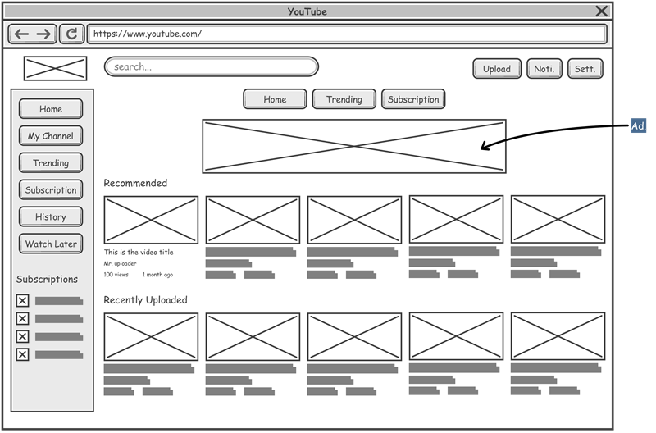

**Figure 2.** Wireframe

Source: https://tinyurl.com/4v444jun

***Hypertext Markup Language***

Hypertext Markup Language (HTML) provides the foundational structure for web pages, as noted by Schwarz, L. (2022). HTML consists of a series of commands, or tags, that instruct a browser on how to interpret content. Specific tags indicate elements such as headlines, paragraph breaks, bold or italicized text, and hyperlinks. For the web to function, three elements are required: a web server, a web browser, and content. HTML serves as a simple language for writing this content. When a page written in HTML is placed on a server, it can be accessed by a web browser. HTML enables basic functionalities such as tagging content for display as headlines, subheadings, and bulleted lists, as well as linking documents.

According to S, A. (2023). HTML has various use cases. In web development, developers use HTML to design how a browser displays web page elements like text, hyperlinks, and media files. In internet navigation, HTML is heavily used to embed hyperlinks, facilitating easy navigation and link insertion between related pages and websites. For web documentation, HTML allows for the organization and formatting of documents, similar to Microsoft Word. It is important to note that HTML is not considered a programming language since it cannot create dynamic functionality, although it is an official web standard maintained and developed by the World Wide Web Consortium (W3C), which provides regular updates.

 Hayes, A. (2022). Further explains that HTML consists of markup symbols or codes inserted into a file intended for internet display. This markup instructs web browsers on how to display words and images on a webpage.

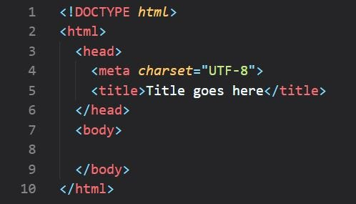

**Figure 3.** Hypertext Markup Language (HTML) Code

Source: https://tinyurl.com/4njhb326

***Cascading Style Sheet (CSS)***

As eloquently stated by Ahmed, A. M., Mohammed, C. N., & Ahmad, A. M. (2023), Cascading Style Sheets (CSS) are essential in web development for designing and styling websites. CSS allows developers to control the layout, colors, fonts, and overall visual presentation of a site. It enables the separation of content (HTML) from design, making it easier to maintain and update. CSS enhances user experience by providing a consistent and attractive interface across different devices and browsers.

Based on Abramowski, N. (2023). CSS is one of the most powerful tools in a web designer’s arsenal. With it, you can drastically alter the entire mood and user experience of a website. Some further benefits you’ll find using CSS are:

* Freedom to position HTML elements anywhere on a web page, while allowing you to keep your markup (HTML) clean and organized.
* Ability to adjust for differences in the way browsers render a web page.
* Endless customization options to a web page including fonts, colors, borders, hover and transition effects, etc.
* CSS preprocessors change the game entirely for developers, allowing them to create more complex layouts more efficiently and use tools such as loops, variables, and if/else statements. You can learn more about it in [our guide to CSS preprocessors](https://careerfoundry.com/en/blog/web-development/css-preprocessors/).
* Ability to easily create, update and maintain styles simultaneously for a large number of web pages.
* Ability to use media queries and relative units (ems and %s) to create web pages which adapt to the user’s screen size—ideal for creating [mobile-responsive web pages](https://careerfoundry.com/en/blog/ui-design/responsive-vs-adaptive-design/).

In addition to Haim, I. (2024). CSS makes websites visually appealing and user-friendly. Its key advantage lies in its separation of content (HTML) from presentation (CSS). This means you can update styles across an entire website with minimal changes to the code.  This efficiency saves time and makes website maintenance a breeze. In short, if HTML builds the house, CSS paints the walls, decorates the rooms, and makes it a place you want to spend time in.

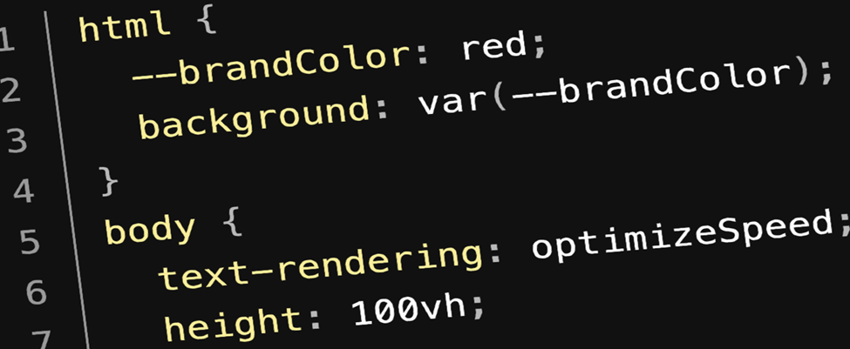

**Figure 4.** Cascading Style Sheet (CSS) Code

Source: https://bit.ly/3Kpciys

***Javascript***

According to Kugell, A. (2024). JavaScript is a fundamental technology in web development, playing a crucial role in creating dynamic and interactive websites. It is the principal client-side programming language used to add interactive elements to web pages, such as animations, form validations, and dynamic content updates without needing to reload the entire page.One of the primary reasons for JavaScript's importance is its ability to enhance user experience by making web pages more responsive and interactive. For instance, JavaScript frameworks like React, Angular, and Vue.js are widely used to build Single Page Applications (SPAs), which allow for seamless navigation and data fetching without full page reloads, thus improving performance and user experience.

Based on Paul, C. (2024). JavaScript is regarded by developers as a crucial language for web design and development for a number of reasons. These are evidently the primary causes;

* Famous as the Most Popular Language Among developers, JavaScript is practically the most widely used programming language. It offers enormous potential for future development and is currently being used to develop a variety of applications. It is a highly sought-after skill that professionals ought to have, according to the industry.
* Easy to Learn JavaScript is far simpler to start using than other programming languages. You can use JavaScript on a web browser without having to install any software on your computer.
* Fun to Work Working with multiple programs in different programming languages can cause stress. With the aid of a graphical user interface, you can deal with the same important issues in JavaScript. When development projects are conducted with this language, work becomes more enjoyable.
* Very Supportive Language JavaScript programming language is still available for free. It offers a sizable network of support teams to assist you with any issue you may run into while the project is still in development. Additionally, the community frequently hosts sporadic JavaScript meetups, which may facilitate your learning.

Moreover, JavaScript is essential for implementing client-side functionalities, such as interactive forms, modal windows, and sliders. It also enables the creation of complex web applications by managing user interactions and updating content dynamically in response to user inputs. (Jayatilleke, B. G., Ranawaka, G. R., Wijesekera, C., & Kumarasinha, M. C., 2019).

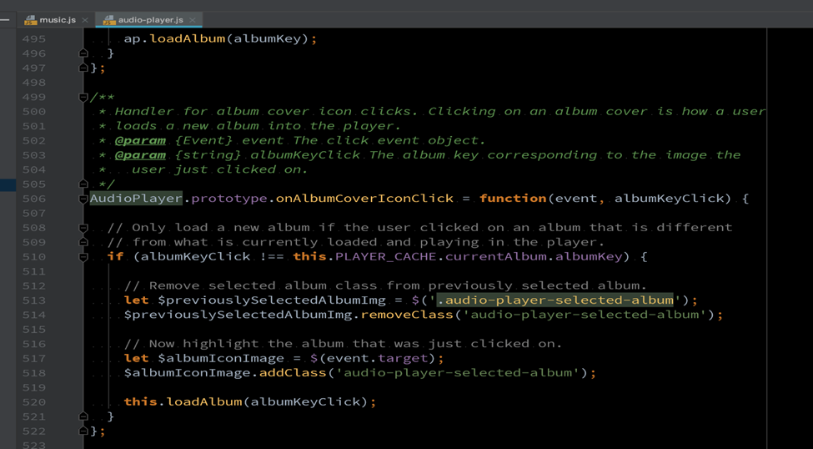

***Figure 5.***Javascript Code

*Source: https://bit.ly/3yC6tex*

***React.js***

According to Fariz, M., Lazuardy, S., & Anggraini, D. ​(2022). Title React or also known as React.js or ReactJS is a Java Script-based front-end library for building user interfaces or UI components. React is managed by Facebook, a community of developers and companies. In a study conducted by Venkat in 2021, it was explained that web development technology before 2015 was about scripting and rendering. At that time HTML and CSS were used for the front-end, while the back-end used PHP. Developer puts static HTML pages in some folders and renders those files using PHP. Developers use this method for decades, so there is no visible revolution on a website until there is a Java Script library like React.js. React.js has several excellent features that make front-end web development faster and more responsive.

Based on Hutsulyak, O. (2024). Being a part of the JavaScript language, using React spawns many advantages. Products built with React are simple to scale, a single language used on the server/client/mobile side of things grants outstanding productivity, there are workflow patterns for convenient teamwork, UI code is readable and maintainable, and more. World-leading companies have used React and other JS technologies in some of the top market-defining products (Instagram, Reddit, and Facebook being the most vivid examples).

In front-end development, the function that react.js plays is becoming increasingly important, providing developers with new options to create new applications. React.js is utilized by a significant percentage of all websites today (Chen, S., Thaduri, U. R., & Ballamudi, V. K. R., 2019).

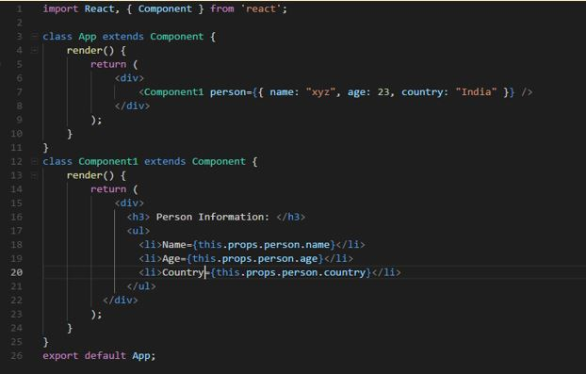

***Figure 6.***ReactJs Code

*Source: https://bit.ly/45084qF*

***Angular***

According to Anastasia, D. (2022). Angular is an open-source web application framework based on TypeScript. It accomplishes various web development activities and improves the app or the website with the required functionalities. Angular supports multiple platforms like mobile, web, and desktop natives.Angular comes as a standalone framework for front-end development and can be used for enterprise software development. If a project is a complicated web app with many features, then Angular is the best choice for this particular project. The reasons why developers and companies choose Angular are: clean code, fast testing, good debugging, and improved CSS class. It’s also worth adding that Angular has a collection of well-integrated libraries. They provide ample opportunities for creating functions, including client-server communication tools, routing, form management, etc. Angular web development is a great solution for projects that need to scale quickly and efficiently. The component base and a wide selection of developer tools provide all the possibilities for simple updating, expanding functionality, high performance, etc.

Angular is a powerful and versatile framework for web application development. With its extensive features, robust architecture, and wide range of capabilities, Angular enables developers to build scalable, maintainable, and efficient applications. While Angular has its advantages and limitations, it remains a popular choice among developers and organizations worldwide. By understanding the key aspects of Angular and its architecture, developers can leverage the framework's full potential and deliver exceptional user experiences (Kaur, N., 2023).

In addition to Deshpande (2023), numerous versions of Angular have been released since its inception, each contributing to the framework's efficiency. Angular allows users to create custom components, packaging functionality and rendering logic into reusable pieces while integrating well with web components. The framework also facilitates data binding, enabling seamless data movement from JavaScript code to the view and responding to user events without manual coding. Additionally, Angular's dependency injection feature allows for the creation of modular services that can be injected as needed, enhancing testability and reusability. Testing is integral to Angular, designed with testability in mind, allowing users to test every part of their application. As a comprehensive framework, Angular offers out-of-the-box solutions for server communication, application routing, and more. Furthermore, Angular is cross-platform and compatible with multiple browsers and operating systems, ensuring that applications can run on browsers like Chrome and Firefox and operating systems such as Windows, macOS, and Linux.

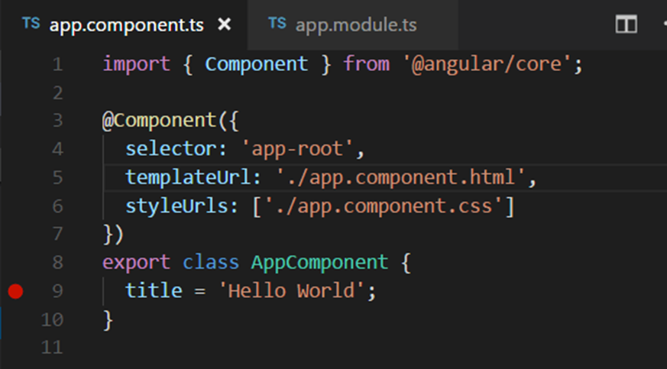

***Figure 7.***Angular Framework Code

*Source: https://bit.ly/3WVHI7g*

***PHP***

According to Singla, L. (2024), PHP stands as a widely used open-source scripting language, particularly renowned for its application in web development. Initially coined as an acronym for "personal home page," PHP now recursively stands for "hypertext preprocessor." Its integration within HTML allows for server-side scripting, empowering developers to generate dynamic content and interact with databases seamlessly. Singla highlights several distinguishing attributes of PHP. Firstly, as a scripting language, PHP is interpreted at runtime, eliminating the need for compilation. Moreover, it operates server-side, wherein a PHP interpreter processes the script on the web server, transmitting the resultant HTML output to the browser. Additionally, PHP's open-source nature fosters accessibility, enabling users to download and utilize it freely. With the advent of PHP5, the language embraced object-oriented programming (OOP), facilitating the creation of intricate and reusable web applications through the utilization of objects. Notably, PHP is lauded for its speed, leveraging memory efficiently to optimize server workload and enhance performance significantly. Comparative benchmarks showcase PHP's superior speed, outpacing languages like Python and Ruby by significant margins. Furthermore, PHP's simplicity underscores its appeal, boasting an easily comprehensible syntax conducive to both novice learners and seasoned developers alike. Singla emphasizes PHP's robust support infrastructure, noting compatibility with leading databases such as MySQL, SQLite, and ODBC, as well as seamless integration with popular servers like Apache and IIS. The language's cross-platform portability further enhances its versatility, with additional support provided by a plethora of frameworks such as Laravel, CodeIgniter, and Symfony, along with a rich assortment of meticulously vetted libraries. Based on S, A. (2024). Anyone can benefit from learning about PHP, but it is even more essential for those interested in web programming. PHP is available on all major operating systems, such as Linux, Microsoft Windows, and macOS. Most web servers, including [Apache](https://www.hostinger.ph/tutorials/what-is-apache) and IIS, also support PHP. One of the main benefits of using PHP is advancing the customization of a WordPress site. Other features include great online support and documentation, so even beginners can learn PHP quickly.

In addition to Bydec, I. (2020). PHP is one of the core languages of web development and has been around since 1995. It has been a part of web development since the start and is one of the most commonly used languages in that field. Many modern web applications are written in PHP, and some websites that use only PHP are among the most visited in the world. As we mentioned, PHP can be used to create any kind of dynamic website, including eCommerce sites. It’s also extremely easy to learn, which makes it ideal for beginners. Generally speaking, the more demanding the website, the more likely it is to be built on PHP. That’s because PHP is an extremely robust language and its core functionality can be extended with a variety of frameworks and libraries. According to Bydec, I. (2020). There are benefits of Using PHP for Web Development:

* Extremely Popular - Popularity is a good sign. It means that more people use it, and more companies are hiring people to work with it. The more people that use a tool, the more likely it is that it’s going to be supported and updated for years to come.
* Easy to Learn - PHP is a great language for beginners. Because it is so widely used, there are plenty of resources available to help you master it and build your skill set.
* Robust - As mentioned, the core functionality of PHP can be extended with a variety of frameworks and libraries. This makes it very robust and ideal for enterprise applications.
* Open Source - This may not be an advantage for everyone, but it definitely is for certain segments of the population. If you don’t have a lot of money to spend on developing your website, or you want to try something new without spending a lot of money, PHP is open source and free.

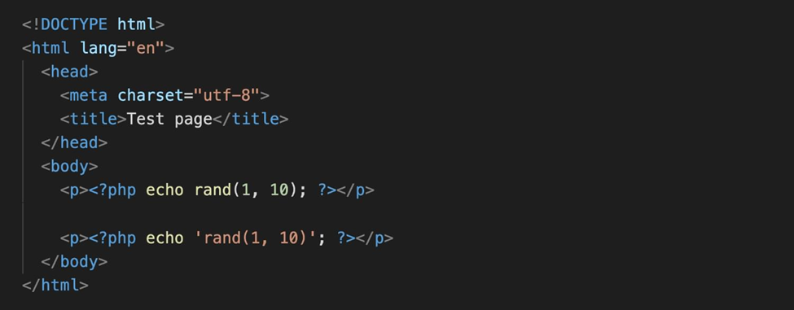

***Figure 8.***PHP Code

*Source: https://bit.ly/3wLMb1L*

***Python***

According to Pitaliya, S. (2024), Python emerges as an interpreted, high-level programming language with dynamic semantics, ideally suited for diverse applications such as Rapid Application Development and as a scripting or glue language to integrate existing components. Renowned for its high-level built-in data structures, dynamic typing, and dynamic binding, Python has garnered popularity as an open-source programming language, offering enhanced process management capabilities. The language facilitates the development of complex multi-protocol network applications while maintaining a straightforward syntax. Notably, industry giants like Google, Instagram, and Spotify leverage Python in their platforms, attesting to its versatility in software development. Pitaliya underscores several reasons to opt for Python, highlighting its adaptability, simplistic and concise code structure, support for cloud computing, dynamic language features, seamless interfaces with other programming languages, and its extensibility and portability. These attributes collectively contribute to Python's status as a versatile and advantageous language choice in software development endeavors.

Based on Kumar, P. (2023). In Python web development, developers use Python to write the server-side logic that powers web applications. This includes handling HTTP requests and responses, managing data storage and retrieval, implementing business logic, and rendering dynamic content.

In addition to Gadhavi, M. (2024).  Web development in Python is a widely adopted approach for creating dynamic websites and applications. With its rich ecosystem of frameworks, libraries, and tools, Python simplifies development and supports scalable solutions. In this comprehensive guide, we will talk about Python web development, explore frameworks, and provide an example of building a web application/system.

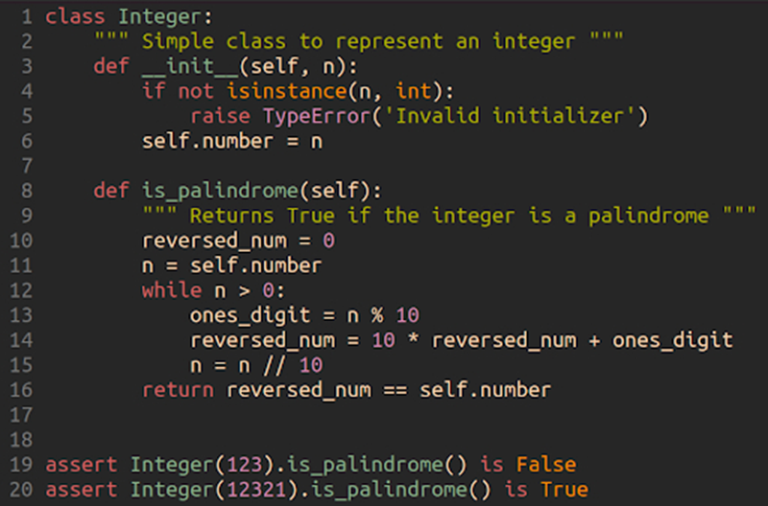

***Figure 9.***Python Code

*Source: https://bit.ly/4aJmsVk*

***Node.js***

According to Sufiyan, T. (2023). Node.js is an open-source, cross-platform JavaScript runtime environment and library for running web applications outside the client's browser. Developers use Node.js to create server-side web applications, and it is perfect for data-intensive applications since it uses an asynchronous, event-driven model.

Based on Bakhur, N. (2024), Node.js functions as a standalone environment for executing JavaScript code separate from the browser. It offers the capability to install on a server, akin to Python, enabling the execution of code and delivery of results to users. With Node.js, developers can create standalone applications utilizing additional frameworks. Prior to the emergence of Node.js, JavaScript applications were confined to browser environments. However, Node.js expands this scope, allowing JavaScript usage not only in browsers but also on servers. Bakhur outlines several benefits of Node.js. Firstly, it boasts high speed, with JavaScript code executing several times faster than equivalent code in languages like Ruby or Python. Node.js leverages an asynchronous programming model, enabling concurrent task execution without waiting for data transfer completion. Additionally, Node.js offers versatility and flexibility by enabling developers familiar with JavaScript to write both client-side and server-side code without the need to learn new tools. Furthermore, developers can swiftly adopt new ECMAScript standards within Node.js, gaining access to new language features upon installing compatible versions. Another advantage lies in Node.js's extensive ecosystem, facilitated by the NPM package manager, which hosts over 500,000 open-source modules and libraries. Lastly, Node.js operates on Google's V8 JavaScript engine, renowned for its efficiency and open-source nature, leveraging the efforts of numerous engineers. This engine, written in C++ with advanced libraries, ensures robust performance and compatibility with Chromium-based browsers, contributing to Node.js's appeal as a development platform. In addition to Khare, M. (2023). Node.js is used for a wide variety of applications. According to the author, these are some popular use cases where Node.js is a good choice:

* Real-time chats - Due to its single-threaded asynchronous nature, Node.js is well-suited to processing real-time communication. It can easily scale and is often used in building chatbots. Node.js also makes it simple to build additional chat features like multi-person chat and push notifications.
* Internet of Things - IoT applications usually comprise multiple sensors, as they frequently send small chunks of data that can pile into a large number of requests. Node.js is a good choice since it’s able to handle these concurrent requests quickly.
* Data streaming - Companies like Netflix use Node.js for streaming purposes. This is mainly due to Node.js being lightweight and fast, besides which Node.js provides a native streaming API. These streams allow users to pipe requests to each other, resulting in data being streamed directly to its final destination.
* Complex single-page applications (SPAs) - In SPAs, the whole application is loaded in a single page. This usually means there are a couple of requests made in the background for specific components. Node.js’s event loop comes to the rescue here, as it processes requests in a non-blocking fashion.
* REST API-based applications - JavaScript is used both in the frontend and backend of sites. Thus, a server can easily communicate with the frontend via REST APIs using Node.js. Node.js also provides packages like Express.js and Koa that make it even easier to build web applications

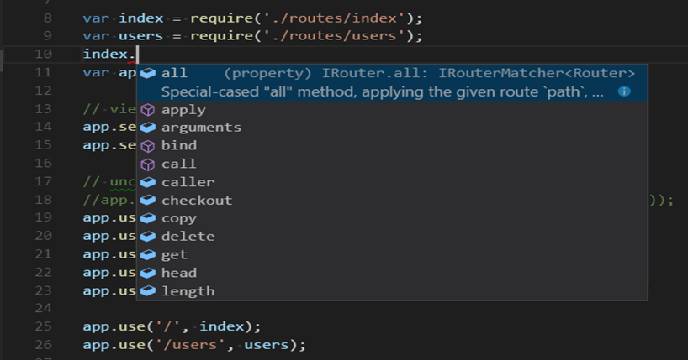

***Figure 10.*** Node.Js Code

*Source: https://shorturl.at/kEGxf*

***MySQL***

According to Giaquinto, R. (2022), MySQL stands as an open-source SQL relational database management system developed by Oracle. In a relational database like MySQL, data is organized into tables, which simplifies data retrieval and enhances organization. For instance, if one stores both customer purchase records and their contact details, MySQL stores each type of data in separate tables, facilitating efficient data management. This relational structure streamlines data retrieval, as one can easily access the specific table containing the desired information. Without the relational database structure, data storage would be less organized, making it challenging to locate relevant information and resulting in redundant data occupying unnecessary space. The efficiency of relational databases like MySQL stems from their ability to minimize redundancy and streamline data organization. Additionally, MySQL allows users to access multiple pieces of data using a unique identifier, known as a key. For example, to retrieve both contact information and purchase history for a customer like John Doe, one would utilize his unique ID to extract relevant data from multiple tables, ensuring comprehensive access to pertinent information.

Dobrovolska, V. (2024). Compares a website to a vibrant city, where the visual elements represent the HTML and CSS shaping its appearance, akin to buildings and streets. However, beyond this facade lies the intricate infrastructure necessary for functionality, akin to the network of pipes and power lines in a city. This underlying framework, managed by back-end technologies like PHP and MySQL, handles crucial tasks such as data management, user interactions, and dynamic content. These technologies ensure the smooth operation of the website, much like the unseen systems that keep a city running efficiently.

In addition to G, D. (2024). MySQL is indeed not the only RDBMS on the market, but it is one of the most popular ones. The fact that many major tech giants rely on it further solidifies the well-deserved position. Here are some of the reasons.

* Flexible and Easy to Use - As open-source software, you can modify the source code to suit your need and don’t need to pay anything. It includes the option for upgrading to the advanced commercial version. The installation process is relatively simple, and shouldn’t take longer than 30 minutes.
* High Performance - A wide array of cluster servers backs MySQL. Whether you are storing massive amounts of big eCommerce data or doing heavy business intelligence activities, MySQL can assist you smoothly with optimum speed.
* An Industry Standard - Industries have been using MySQL for years, which means that there are abundant resources for skilled developers. MySQL users can expect rapid development of the software and freelance experts willing to work for a smaller wage if they ever need them.
* Secure - Your data should be your primary concern when choosing the right RDBMS software. With its Access Privilege System and User Account Management, MySQL sets the security bar high. Host-based verification and password encryption are both available.

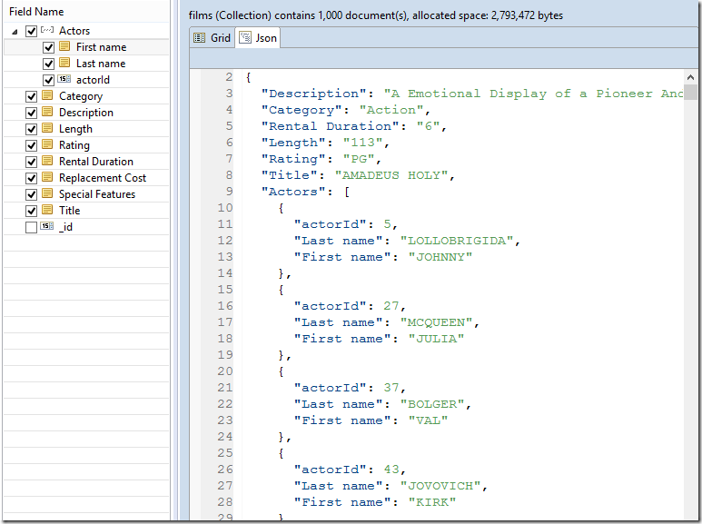

***Figure 11.***MySQL Code

*Source: https://tinyurl.com/3cbr3nu8*

***Laravel***

According to Jalli (2022), Laravel stands out as a user-friendly web framework suitable for creating scalable PHP-based websites and applications. Prior to embarking on a web development project, one faces the crucial decision of selecting the appropriate technology, which often proves to be a challenging aspect of the process. Laravel emerges as a favorable choice, offering an open-source platform that simplifies the creation of modern web applications on a large scale. Several notable features contribute to its popularity among developers. Firstly, Laravel adopts the MVC architectural pattern, promoting the creation of scalable and maintainable web apps by providing structured guidelines. This approach brings organization and consistency to coding practices, facilitating the development of both small and large-scale applications. Additionally, Laravel incorporates Artisan CLI, a command-line interface that streamlines various development tasks such as data migration, database management, and code generation. This feature enhances efficiency by enabling developers to focus on the application's logic rather than getting bogged down in repetitive setup processes. Furthermore, Laravel offers built-in solutions for authentication and authorization, simplifying the implementation of reliable security measures with just a few Artisan commands. These features collectively contribute to Laravel's reputation as a versatile and efficient framework for web development. Laravel (a top PHP framework) is behind some amazing web applications/system with a superior personalized experience for users. PHP and Laravel allow impeccable syntax to enable coding with a minimal chance of errors. By [hiring expert Laravel developers](https://techliance.com/hire-laravel-developers) businesses can make error-free web-based solutions that deliver the best experience to users. This framework is powering various types of web-driven projects and products. Laravel enables the development of websites that help in facilitating specific requirements. Especially, it perfectly suits coding server-side of customer-facing applications like eCommerce portals. Arguably, one of the most popular web application/system frameworks, Laravel provides ease in common [website programming](https://blog.techliance.com/web-development/) tasks. For instance, authentication, routing, sessions, and caching. It uses PHP as a back-end programming language for coding applications (Techliance, 2024).

In addition to [Stickman](https://www.linode.com/docs/contributors/nathaniel-stickman/), N. (2021). With Laravel, you can easily spin up a new website while also having the features and scalability to handle advanced and large-scale applications.

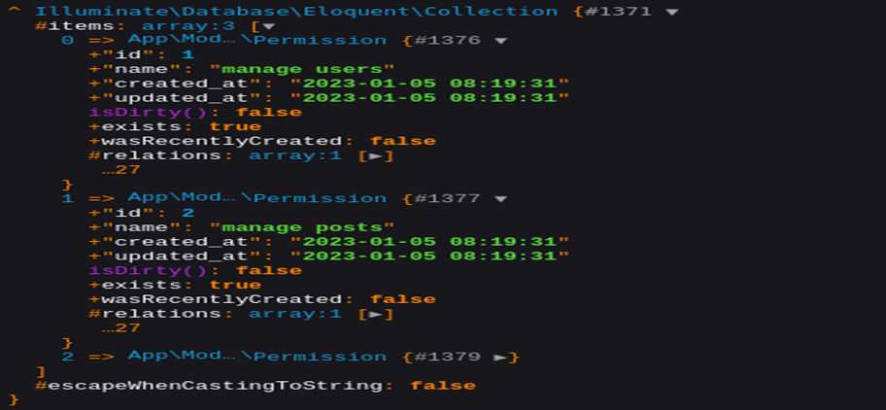

***Figure 12.***Laravel Framework

*Source: https://shorturl.at/8kG9f*

***Django***

According to Nihar-Raval. (2023). Django is an open-source web app development framework based on [Python programming](https://radixweb.com/python-development) language. It is used to develop backend web applications. Its key objectives are integrating reliability, scalability, adaptability, and simplicity into the web development process. The Django Python web framework, being open-source, regularly introduces new Django MVT architecture and updates to improve its features and address the needs of its users. Some of its essential features include:

* Object-Relational Mapping (ORM) - Django's ORM maps database tables to Python classes. Thus, it is incredibly easy to work on databases without having to write SQL queries.
* Authentication and Authorization - With a robust authentication and authorization system in place, Django allows you to seamlessly manage user authentication and permissions.
* Admin Interface - The admin interface provides an out-of-the-box dashboard for [managing data in the database](https://radixweb.com/database-management). It is highly customizable and you can extend it to include personalized functionalities.
* Internationalization - It supports internationalization and localization, making it easy to create multilingual [websites or web apps](https://radixweb.com/blog/web-app-vs-website) based on demographics.
* URL Routing - The URL routing system enables developers to define URLs to view functions or methods. and create clean, readable, and scalable URLs.
* Templating Engine - Django has a built-in templating engine to create dynamic web pages by allowing developers to mix HTML with Python code.

Based on Smith, O. (2022). It provides a lot of features to the developers "out of the box," so development can be rapid. However, websites built from it are secured, scalable, and maintainable at the same time. Some features of Django include a lightweight and modular design, a powerful ORM (Object-Relational Mapper) that simplifies database interactions, and built-in support for common web development tasks such as user authentication and management, form handling, and content administration.

In addition to Mahalias, I. (2024). *Here are the advantages of the Python Django framework:*

* Security - Keeping everything aside, data security is the primary concern for every business in every industry. Django is a trustworthy platform with built-in protection for request forgery, clickjacking, cross-site scripting, and SQL injection. Being a high-end full-featured framework, Django contains an impressive built-in toolbox that is thoroughly tested and has a predictable release cycle. Thus, everything stays secure and in the control of the developer.

### Performance - As it’s a Python-based framework, Django offers incredible performance. It comes with Django’s exceptional documentation that gathers relevant links and aids performance during the development processes. Also, you have access to lots of tools that boost productivity when you need them. For example, the Django Caching framework aids performance with several levels of cache granularity. It prevents the calculation of dynamic content for each request and enhances your site performance. However, it only works if your code is running perfectly as expected.

### Simplicity - The reason is that it’s Python-based and pluggable modules for the developer’s convenience. Django features included batteries such as Object Relational Mappers (ORMs), Forms, Testing, Templates, and Authentication Mechanism. Django is easy-to-use and productive enough for web development because you don’t need to create these modules from scratch.

### Support & Community - Being an open-source framework, Django is reliable and offers you complete access to your website. But there’s one more thing that describes the trustworthiness of Django over other web frameworks. It’s Django’s massive community of over thousands of contributors. The [Python developers](https://www.planeks.net/python-development/) in the community keep introducing new libraries to solve most coding issues. In simple words, even if you’re searching for a common issue, you will surely find out the issue has already been solved by the community.

### Built-in Admin Panel - Many web frameworks oblige you to invest your time building your own admin panel. Fortunately, that doesn’t happen with the Django framework, as it features an in-build web interface. You get access to a customizable and versatile admin panel with required permissions and authentication modules. Moreover, Django’s built-in admin panel also supports the addition of third-party applications and wrappers.

### Scalability - Django is highly used because of its scalability and helps you minimize the cost when it comes to project growth. It’s a pluggable framework that allows you to add or remove decoupled components during the scalability. Whether site traffic or mobile app API, Django can help you scale your website to support over 400 million users. Besides this, Django features loosely coupled architecture that supports the addition of hardware at any point. Unlike other frameworks, any hardware addition does not affect the working of already used components.

### Libraries - This framework is definitely a great option for web development, thanks to the large collection of built-in libraries. You get access to productive libraries such as Django REST Framework, Celery (distributed task queue), Sentry(app monitoring), and other packages that simplify and speed up the development. Whether you want to [develop an API](https://www.planeks.net/api-integration/) or mobile apps backend, Django libraries meet all your development needs. That’s why we consider libraries as among the top advantages of Django for web development.

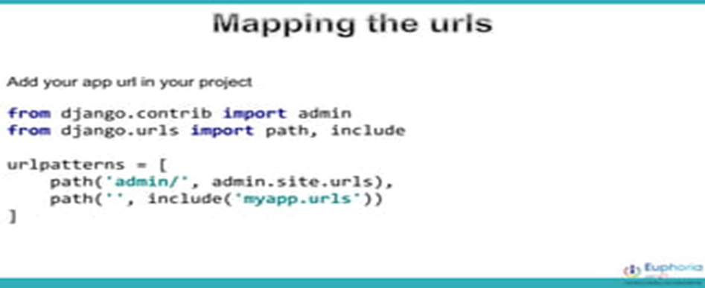

***Figure 13.***Django Framework

*Source: https://tinyurl.com/msr23hk7*

***Express.js***

According to Eseme, S. (2023). Express.js, sometimes also referred to as “Express,” is a minimalist, fast, and Sinatra-like Node.js backend framework that provides robust features and tools for developing scalable backend applications. It gives you the routing system and simplified features to extend the framework by developing more powerful components and parts depending on your application use cases.

Based on Ghosh, D. (2023). Express.js is a powerful web application/system framework for Node.js that offers a wide range of features, such as a robust routing system, middleware support, and template engine integration. It’s an easy-to-learn and versatile framework that can be used to build a variety of web applications/system. With an active community of developers and third-party plugins, Express.js is continuously evolving, making it a top choice for web development. So, whether you’re a newbie tech enthusiast or an experienced developer, learning Express.js can take your web development skills to an advanced level.

In addition to Katariya, L. (2023). Express.js is a flexible framework that lets developers do their thing. You can mix and match middleware, pick your favorite templating engines, and even choose databases that fit your project. It's like having a toolbox of tools at your disposal. For example, if you need to build a real-time app, you can use Express.js with middleware like Socket.io to add real-time functionality to your app. Or, if you need to build a single-page app, you can use Express.js with a templating engine like Pug to render your HTML views. It is also lightweight and easy to use. It gives developers a lot of control over the architecture of their applications, which can be helpful for building customized and complex applications.

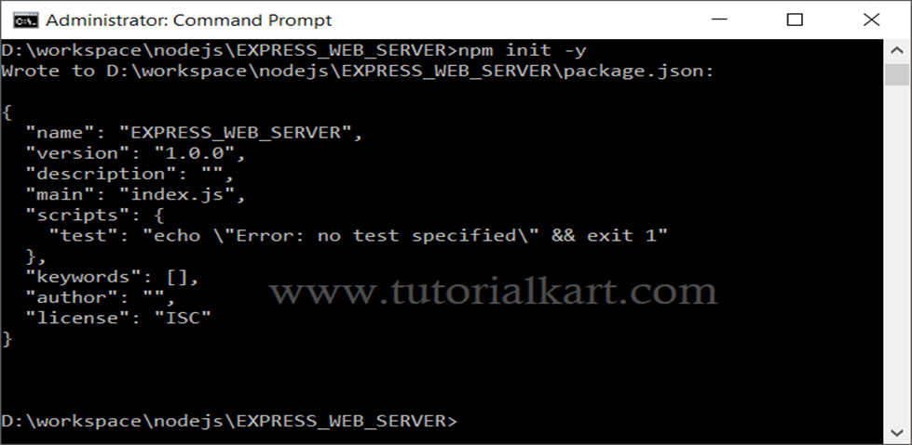

***Figure 14.***Django Framework

*Source: https://tinyurl.com/mw9pxrb3*

***Bootstrap***

According to Alexandrea, J. (2023). Bootstrap is an invaluable tool for web developers and, by using it, can avoid laboring for basic up functions for fast website development Bootstrap is full of web design features and components that use HTML, CSS and JS scripts. It does so for several reasons. The first point is that Bootstrap is very popular for its beginner friendly because it has a lot of tutorials and resources for that newbies. Simple file based (HTML CSS JS) unless you know enough that you are already using some html framework you can insert or modify the app in to. In addition to that, Bootstrap makes it easy to develop faster, with precompiled files and themes that are widely used in the most popular content management system such as WordPress. Moreover, with the help of Bootstrap's responsive grid system, you can avoid manual creation by having a set of rows and columns ready to specify layout with much ease. This grid system will also target laborious data entry tasks, and establishes a pattern for creating customized breakpoints on a per-project basis. And finally, the bourgeoning Bootstrap evokes the amounts of browser compatibility at least to that available by recent popular browsers, thereby increasing the web surf rate, ostensibly strengthening your site's positioning in search engines. Together, these features make Bootstrap the ideal option for web projects striving for the most rapid development speed and full platform and browser consistency.

Based on Ouellette, A. (2023).  Bootstrap saves you from writing lots of CSS code, giving you more time to spend on designing webpages. Bootstrap is a powerful tool that allows a developer to get up and running quickly and painlessly. It makes it easy to integrate many great features that enrich a user’s interaction with the web without having to code them from scratch. In addition to Singh, U. (2024). Bootstrap is one of the most popular frameworks for building websites and web apps. It is a great tool for web developers and designers because it:

* Speeds up development
* Makes responsive design easier and more consistent
* Allows you to customize your site without coding

He concluded that the most significant aspect of Bootstrap is its responsive grid system, which allows creation of websites that are easily adaptable for multiple devices.

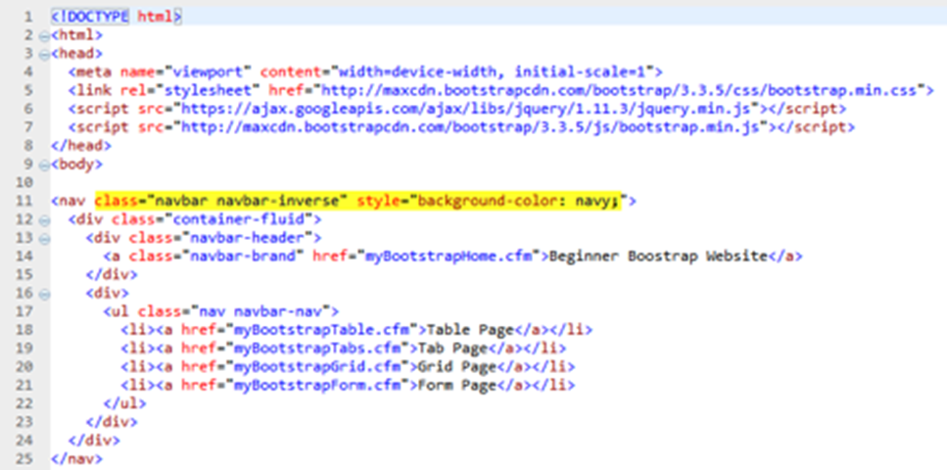

***Figure 15.***Bootstrap Framework

*Source:https://tinyurl.com/bdbhdwwe*

***GitHub***

According to Gaba, I. (2023). GitHub is a Git repository hosting service that provides a web-based graphical interface. It is the world’s largest coding community. Putting a code or a project into GitHub brings it increased, widespread exposure. Programmers can find source codes in many different languages and use the command-line interface, Git, to make and keep track of any changes. GitHub helps every team member work together on a project from any location while facilitating collaboration. You can also review previous versions created at an earlier point in time.

Based on Lutkevich, B., & Courtemanche, M. (2023). GitHub facilitates social coding by providing a hosting service and [web interface for the Git code repository](https://www.techtarget.com/searchitoperations/video/Top-differences-between-GitHub-and-Git), as well as management tools for collaboration. The developer platform can be thought of as a [social networking](https://www.techtarget.com/whatis/definition/social-networking) site for software developers. Members can follow each other, rate each other's work, receive updates for specific opensource projects, and communicate publicly or privately.

According to them, the following are some important terms GitHub developers use:

* Fork. A [fork](https://www.theserverside.com/blog/Coffee-Talk-Java-News-Stories-and-Opinions/command-line-GitHub-fork-CLI-terminal-shell), also known as a branch, is a repository that has been copied from one member's account to another member's account. Forks and branches let a developer make modifications without affecting the original code.
* Pull request. If a developer would like to share their modifications, they can send a pull request to the owner of the original repository.
* Merge. If, after reviewing the modifications, the original owner would like to pull the modifications into the repository, they can accept the modifications and merge them with the original repository.
* Push. This is the reverse of a pull -- a programmer sends code from a local copy to the online repository.
* Commit. A [commit, or code revision](https://www.theserverside.com/blog/Coffee-Talk-Java-News-Stories-and-Opinions/gitkeep-push-empty-folders-git-commit), is an individual change to a file or set of files. By default, commits are retained and [interleaved onto the main project](https://www.theserverside.com/feature/Why-GitHub-renamed-its-master-branch-to-main), or they can be combined into a simpler merge via commit squashing. A unique ID is created when each commit is saved that lets collaborators keep a record of their work. A commit can be thought of as a snapshot of a repository.
* Clone. A clone is a local copy of a repository.

In addition to Juviler, J. (2024). The single biggest selling point of GitHub is its set of project collaboration features, including version control and access control. To illustrate what’s possible with GitHub, imagine this scenario. You want to code an online game, and you enlist your friend to help you.You create a repository on GitHub that stores all the files, including current and past versions, then give your friend collaborator access to this repo as well. A robust [online portfolio](https://www.theforage.com/blog/basics/online-portfolio) shows employers your [programming skills](https://www.theforage.com/blog/skills/programming-skills) and experience using common tools like GitHub. Through your public profile on GitHub, potential employers can gain insights into your organization, coding, and developing skills. In addition to including previous work in your portfolio, highlight your familiarity with GitHub and Git in job or internship descriptions on your [resume](https://www.theforage.com/blog/basics/what-is-resume). Including specific details about projects you’ve done, even if they’re not featured in your GitHub portfolio, can be beneficial. One great aspect of GitHub is you can use it to gain experience even if you don’t have any prior professional jobs or internships in coding or programming. Using open-source projects or building your own can help you develop a portfolio of work that speaks for itself outside of your resume or [cover letter](https://www.theforage.com/blog/basics/how-to-write-a-cover-letter) (Girardin, M. (2024).

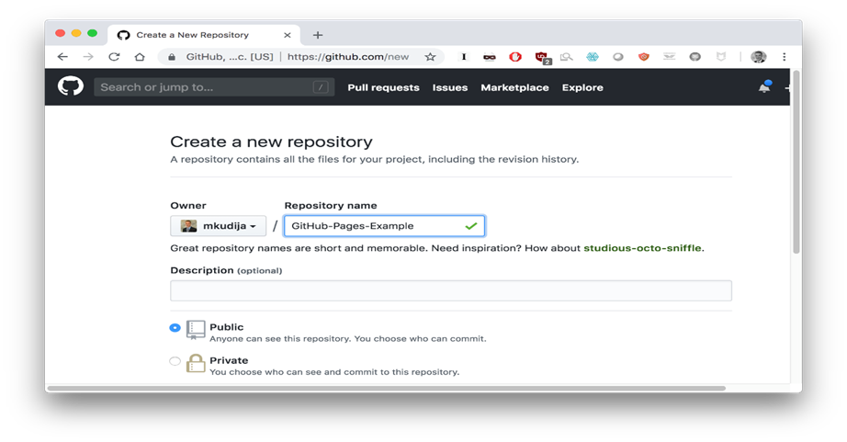

***Figure 16.***Github Interface

*Source:https://tinyurl.com/mr246pap*

***Canva***

According to Gareth (2023).  [Canva](https://www.canva.com/)is an online graphic design tool pre-loaded with thousands of templates to spark your creativity. Whether it be for internal use or for a client, the many benefits of using Canva make it easier than ever to knock up stunning visuals in no time. From magazines to [website design](https://welfordmedia.co.uk/services/web-design) to logos, Canva helps you design everything simply and efficiently without needing extensive graphic design experience or complicated Adobe programs. *Here are the benefits of using canva:*

* Create wireframes with ease.
* Pre-made size templates make creating size-specific content simple.
* The ability to use the transparency tool on all elements.
* Hundreds of elements, icons and graphics to choose from.
* The ability to add frames and vignette to imagery.
* The user-friendly interface is easy to use for all levels.
* The free design templates make designing content super quick.
* Access to free, safe stock imagery.
* Comment and collaborate with team access.
* There are endless possibilities for creation.

In addition to Clark, H. (2024). Canva enables you to create visually appealing websites in minutes. It is the perfect platform for beginners with little to no experience. Canva features an easy-to-use drag-and-drop website editor and a vast database of design templates, royalty-free images, and graphics. As a result, your web design process becomes quick, simple, and extremely cost-effective.You may use Canva online or by downloading the app for your Mac, PC, Chromebook, iOS, or Android device. Canva offers thousands of free templates and over 250,000 free photos, icons, illustrations, graphics, social media elements, videos, animations, and more that you can easily drag and drop into your website. The platform has other features, such as Styles, to help you find the perfect color and font combinations for image editing. Additionally, Canva features Magic Write, an AI writer & text generator powered by OpenAI and canva ships a color palette generator to create custom color palettes. Canva also allows you to add brand elements to your sites. Subsequently, Canva stores your logo, brand colors, and fonts in its Brand Kit. Stunning graphics can play a huge role when it comes to marketing your business and attracting customers. [Canva](https://www.elegantthemes.com/blog/refer/canva) offers a simple, free solution to help you create amazing professional designs with little effort. The biggest decision you’ll have to make is which types of graphics to focus on for your business (Hughes, J. (2023)

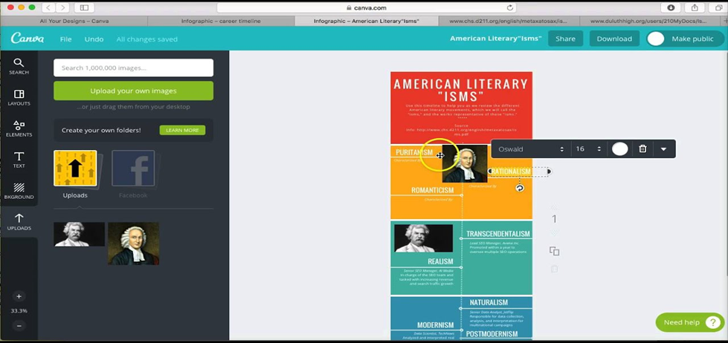

***Figure 17.*** Canva Interface

*Source:* *https://tinyurl.com/mr29v7x3*

***Adobe XD***

According to Ap, B. (2021). You won’t develop a website or app indeed, through the Adobe Xd, you will design/prototype your system screens there. Therefore it is a useful tool for UI and UX professionals to validate a system usability concept, before starting code. You must think that you’re “spending time”, in a concept validation initial step, to be more assertive in the future, when you start to code your website/app. This is an important User experience concept. You have to test, test, and test again before going around coding. Adobe Xd is also a useful tool to create wireframes (that low fidelity prototypes), that are helpful when you want to quickly validate system usability without spending much time and before thinking about the layout.

Based on Lynch, L. (2022). Adobe XD relieves that burden by allowing us to design interactive elements, including dropdown navigation, pop-ups, and mobile touch-based behaviors. It’s also possible to incorporate links within the document, making it easier to demonstrate a specific kind of user flow. We can even share a link to the design document with our clients so that they can view the designs in their web browsers, as if it were a real website. All this makes it easier for them to envision what the final product will be like, and to provide feedback based on that prototype without worrying about whether they’ve understood our designs correctly.

In addition to Mishra, D. P., Rout, K. K., & Salkuti, S. R. (2021). For any Web application, its interface and design play an important role in business, because it directly reflects a customer’s usage. More the customers are satisfied, it helps in growing your business, you get many more customers. Keeping this in mind, it’s hard to straight away start designing the UI without having a feel of how our application would look like to our customers. This is where a need for UX arises. The most popular tool for UX/UI designing in Adobe XD. It’s user-friendly with many features and is available for both macOS and Windows. The part that any web designer would like about this software is that it gives a feel of the application we intend to make, a functional application, and design. So a developer could make a rough sketch of their entire application along with the design and its functionaries like a pop-up window (a modal in CSS), the link between pages in the web application, animation effects, fill color property, and many more. One more major advantage to a UI designer is that the names of the features used in Adobe Xd are the same in coding CSS properties.

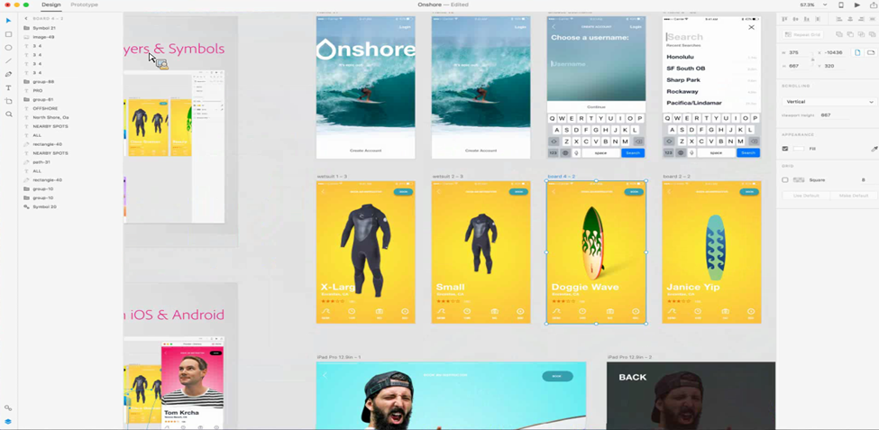

**Figure 18.** Adobe XD Interface

Source: https://tinyurl.com/ykh2s9kk

***Figma***

According to Writes, B. (2023). Figma is primarily a browser-based design tool. Whether you’re using Chrome or Safari, Figma’s browser compatibility ensures a smooth, feature-rich experience without heavy software installations. You can use it on any device with an internet connection. However, you can also install Figma’s desktop app. It’s supported on MacOS, Windows, and Linux. Irrespective of your operating system, Figma remains consistent in its offering, ensuring a familiar and intuitive interface. And if you’re on the go and want to make some quick changes to your design when the inspiration kicks in, you can install the Figma mobile app on iOS and Android. Perhaps even more importantly, the browser version and app have almost the same features so you won’t miss out on anything, no matter your choice. As a fully remote agency owner, the author finds this cross-device compatibility invaluable. It means that my team, regardless of their location, device preference, or operating system, can collaborate effectively and efficiently.

Based on Fernandes, J. (2023). A wireframe allows the designer to work with a client or developer and walk through the structure of the website without getting sidetracked by other elements such as colors, images or illustrations. When working with large sites, wireframing helps the designer determine which elements should be included on the page and which functionality needs to be set for each section. While there are no hard and fast rules to where you can create wireframes, be it a low fidelity wireframe on paper or a high fidelity one on software, on Figma, you can create wireframes by making use of pre-existing tools that you would use to make your final website. You can use the frame tool, which has presets of desktop and mobile sizes, or create your own dimensions. You can add grids (columns and rows) to your wireframe and create rectangles to denote where the elements on the page would be placed. This is essentially your blueprint for your website.

In addition to Martinez, P. (2023). Since Figma is a web-based tool, you can access it on any browser or computer of your choice. Also, you can find a wide range of designing tools in Figma to create wireframes of low and high fidelity. Besides that, there are several other designing and interactive options that you can explore in Figma. To use Figma for wireframing, According to the author, *these are the recommended following steps:*

* Step 1: Get the Figma Wireframe Kit - Firstly, you can just go to the official website of Figma and access its online tool. Though, if you want to save your time, then you can get a readily available Figma wireframe kit from its website and include it in your account. There are all kinds of templates and designs in the kit to help you do wireframing in Figma easily.
* Step 2: Include the basic design elements - On the web interface of Figma, you can see all kinds of design elements on the side. All you need to do is just drag and drop the element and include it on your canvas. You can further adjust its CSS by changing its color, size, alignment, and so on. By following the same approach, you can work on multiple frames. For instance, if you want to create a wireframe of an app on Figma, then you can have different screens for it. You can just copy a design element and reuse it multiple times to provide a uniform appeal to your wireframe.
* Step 3: Finalize your Figma wireframe design - Using the same design elements, you can also create different versions of the Figma wireframe as well. In the end, you can use its inbuilt tool to link various screens and components of your wireframe with each other. This will provide high fidelity in the wireframe for Figma project of yours. When you are done, you can go to the Observation Mode of Figma to get a real-time preview of how your wireframe design would look like. Later, you can also share this design with others and save it to the cloud.

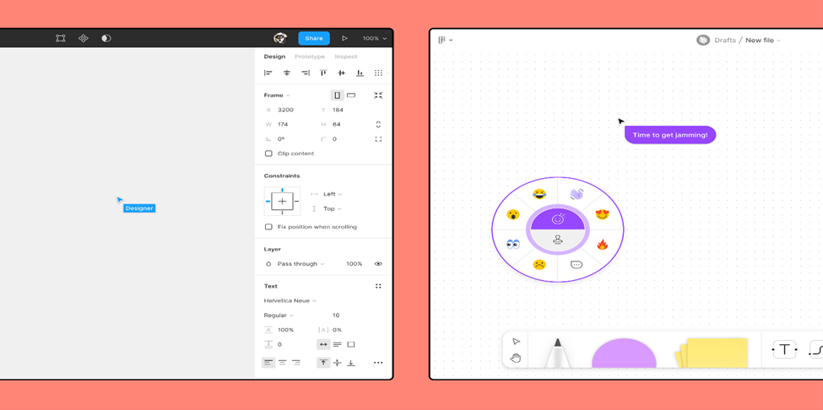

**Figure 19**. Figma Interface

Source: https://tinyurl.com/224tscp6

***Visual Studio Code***

According to Murali, M. (2023). When developers collaborate on coding projects and debugging, they typically do so through an integrated development environment (IDE). Microsoft’s Visual Studio is one of the most popular IDEs and has been around for 25 years. Visual Studio IDE allows programmers to create and edit their code collaboratively. It has extensions and includes tools to assist in building code. This lets you see in real-time what your teammates are working on so you can reduce redundancies. It has code completion with syntax highlighting, an AI coding model to assist with programming, and an analysis tool to help you with debugging.

Based on Quoy, L. (2024), there are pros to using Visual Studio Code (VSC):

* Comprehensive Development Environment: Visual Studio Code comes with a wide range of development tools pre-installed, eliminating the need for separate installations.
* IDE Capabilities: It functions as a robust Integrated Development Environment (IDE), supporting project building, interactive debugging, and code profiling.
* IntelliSense: Provides intelligent code suggestions, which are especially useful for languages like C++, enhancing coding efficiency.
* Advanced Code Profiling: Allows for in-depth code analysis and fine-tuning to achieve optimal performance.
* Team Collaboration: Includes built-in features that facilitate collaborative development, making it suitable for larger projects.
* Customized Language Support: Adapts to the specific programming language being used, offering tailored features and support.

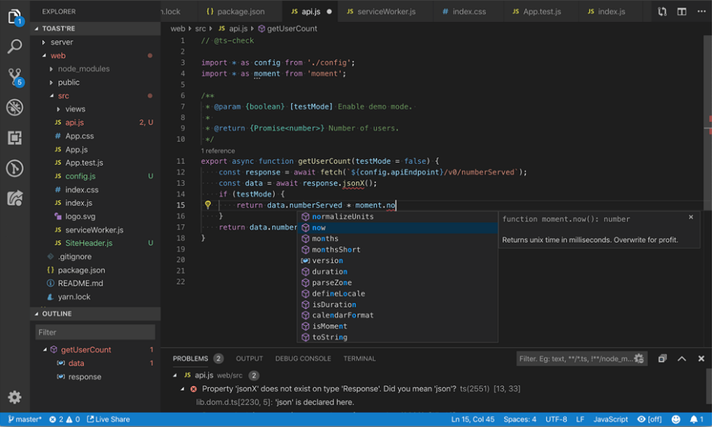In addition to Mir, M. A. (2023), there are several advantages to using Visual Studio Code (VSC). Visual Studio Code provides robust support for a wide range of programming languages, including Java, Python, C++, JavaScript, and more. It features syntax highlighting, code completion, and language-specific tools, making it an excellent choice for developers working with multiple languages. Additionally, Visual Studio Code is a powerful code editor with many features, such as Git integration, debugging tools, and extensions that allow for workflow customization. The high customizability of Visual Studio Code enables developers to configure the interface and keyboard shortcuts to their preferences, making it suitable for those who want to tailor their coding environment to their specific needs. Furthermore, Visual Studio Code boasts a large community of developers who create and maintain extensions and plugins, adding new functionality to the editor. This extensive range of extensions can enhance the coding workflow. Lastly, Visual Studio Code is known for being fast and efficient, with a small footprint, making it an ideal choice for developers seeking a code editor that does not slow down their computer.

**Figure 20.** Visual Studio Code Interface

Source: https://tinyurl.com/yj4avfpv

***ISO25010***

According to Britton, J. (2021). ISO 25010, titled “Systems and software engineering – Systems and software Quality Requirements and Evaluation (SQuaRE) – System and software quality models”, is a software quality standard. It describes the models, consisting of characteristics and sub-characteristics, for both software product quality, and software quality in use together with practical guidance on the use of the quality models.

ISO25010 describes two quality models: The first is the quality in use model composed of five characteristics (some of which are further sub-divided into sub-characteristics) that relate to the outcome of interaction when a product is used in a particular context of use. Second is a product quality model composed of eight characteristics (which are further sub-divided into sub-characteristics) that relate to static properties of software and dynamic properties of the computer system. Based on Britton, J. (2021). The characteristics and sub-characteristics provide consistent terminology for specifying, measuring and evaluating system and software product quality. They also provide a set of quality characteristics against which stated quality requirements can be compared for completeness. Britton, J. (2021) stated that, ISO 25010 describes eight primary product quality characteristics and 31 sub-characteristics that collectively define software quality. These characteristics encompass functional suitability, reliability, performance efficiency, usability, security, compatibility, maintainability, and portability. Each characteristic comprises specific attributes that contribute to assessing the quality of software products. For instance, functional suitability evaluates how well a product meets stated and implied needs, while reliability gauges the system's ability to perform under specified conditions. Performance efficiency considers resource utilization and time behavior, while usability examines the ease and effectiveness of achieving goals. Security focuses on protecting information and data, whereas compatibility concerns the product's ability to function within various environments. Maintainability assesses the ease of modifying, improving, or adapting the software, and portability evaluates its transferability across different environments. Additionally, Britton emphasizes that software quality encompasses adherence to design principles and non-functional requirements such as security and maintainability, as outlined in ISO 25010. Software quality measurement quantifies the extent to which software aligns with each characteristic, evaluating aspects like testability, ease of understanding, and ease of editing without introducing errors. These assessments provide valuable insights into the overall quality and performance of software products.

In addition to Rebes, P. (2024), in "Is ISO 25010 Standard Good for Everyone?", each project is different, so the list cannot be treated as a ready-made plan of action. It is essential to first consider what is important for the client and the user, from the very beginning of work with the client. Rebes, P. emphasizes that every organization benefit from "best practices" and predictability. Process standardization and automation of testing save considerable time and money, and help protect against common bugs. However, predicting obstacles and errors cannot be added to the product after it is already built.

Rebes, P. further suggests that it is beneficial to include a QA team member in workshops with the client to ensure the client understands the role QA plays in the development process. A QA specialist can identify potential challenges early on and propose solutions. Even during the software creation process, it is useful to keep the ISO standard in mind, regardless of one's specific role, such as a frontend QA. ISO 25010 serves as a great framework for defining important software metrics for a particular project. It is not a comprehensive, detailed map, but rather a guide that can be used according to the circumstances. Every development project has different priorities and metrics, and this standard allows enough flexibility to accommodate all of them.

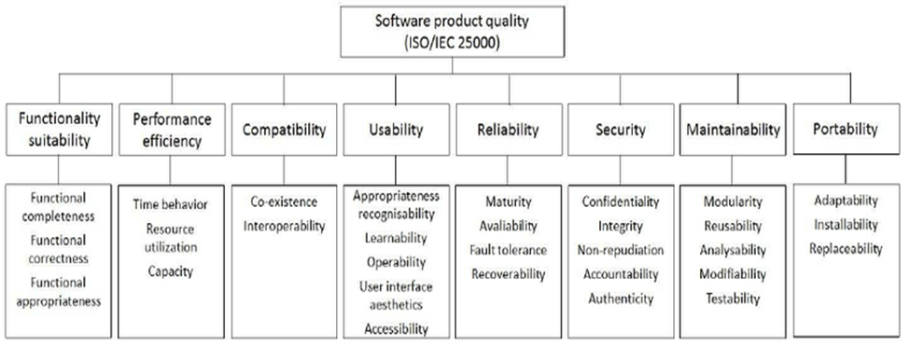

**Figure 21.** ISO25010 Software product quality

Source https://tinyurl.com/yc5e8t4a

**Review of Related Studies**

***Digital Human Resource Management Platform based on ChatGPT***

According to Jinbo Zhou, & Weiren Cen (2023).  Digital human resource management platform based on ChatGPT demonstrates significant advantages in personalized employee experiences, decision-making efficiency, and work productivity, holding greater potential and value compared to conventional human resource management platforms. Nevertheless, successful application of the platform necessitates further exploration and refinement to address data privacy and security concerns, provide appropriate training and support, and continuously improve and innovate platform functionalities and performance.

***Research on performance management of ground service staff in Xiamen Airlines***

According to Ye, S. (2024). An effective performance appraisal mechanism is crucial to motivate employees and improve service levels.Within the framework of human resource management, performance management plays a central role.which helps airlines maintain their advantages in the fierce market competition. In order to achieve this purpose, airlines must analyze the current performance evaluation system in depth and implement corresponding improvement measures. Such a reform can not only promote the improvement of individual employee performance, but also enhance the service quality and market competitiveness of the whole airline.

***Digital Human Resource Practices and Employee Development in Nigerian Banking Sector***

According to Okoro, G. O. (2024, May 2) as dimensions of digital human resource practice while measures of employee development were performance management and competence development. Study revealed that digital human resource practice is imperative and essential to employee development in the Nigerian banking sector. Digital human resource practice and employee development have become integral components of the Nigerian banking sector. By adopting digital HR practices, banks can enhance recruitment processes, improve employee training and development, streamline performance management, foster employee engagement, and retain top talent.

***Digitalized talent management and automated talent decisions: the implications for HR professionals***

Based on Wiblen, S., & Marler, J. H. (2021).By employing a qualitative case study with multiple embedded units of analysis, they show how the same digital talent management technology produced different ways of identifying talent even within the one organisation. Role of digitalisation plays in how various stakeholder groups (HR and line managers) identify talents and whether digitalisation transforms the role of HR professionals in identifying talent. In one social context, the material properties of the technology dominated, while in another the existing social context and relationships prevailed over the material properties of the technology. The findings They've discovered have implications for understanding digital transformations by acknowledging what factors influence the role that digitalisation and automation have on the perceived legitimacy of HR professionals.

***Recruiting digital talent: The strategic role of recruitment in organisations’ digital transformation***

According to Gilch, P. M., & Sieweke, J. (2020). Found that the recruitment of digital talent as a new target group triggers change within the company, and does so in three ways: First, recruiters have realised the necessity to adapt their measures and processes to the new target group. Second, recruiters have developed a new self-understanding. Third, recruiters have recognised the need to support the organisation’s digital transformation by taking on a bridging function. Recruitment plays a central role during digital transformation because companies in many industries need to hire employees who possess IT-related knowledge, skills and abilities to digitalise their products, services and processes. The study they make has two contributions: First, they identified two new roles for recruitment during digital transformation: It acts as a ‘sensory organ’ that enhances the organisation’s absorptive capacity; and it takes on the role of a ‘mediator’ between external and internal groups. Second, Study builds on the human resources (HR) literature by analysing the strategic implications that digital transformation imposes on recruitment, highlighting recruitment’s part in renewing an organisation’s human resource base, which is crucial for its digital transformation.

***Digital human resource development: where are we? Where should we go and how do we go there?***

According to Thite, M. (2020). The evolution of HR-Technology interface is leading up to the incorporation purposely to trace the digital world in Human Resource Development’s design thinking, strategizing and execution. The purpose of the study is to trace the evolution of HR-Technology interface leading up to the incorporation of the digital world in Human Resource Development’s design thinking, strategizing and execution. The paper presents a comprehensive framework that encompasses external demands, internal capabilities and key recommendations for a fit-for-purpose, future-focused Digital HR Strategy. it critically analyzes Digital HR in terms of where it is now (degree of alignment between external demands and internal capabilities), where it should be (future-focused HR technology strategy), and how it can reach there (implementation road map). In the process, the Study adopts a holistic perspective of virtual HRD (VHRD) and draws implications for technology-led developments in the HRD field.

***The Influence of Social Networks on the Digital Recruitment of Human Resources: An Empirical Study in the Tourism Sector***

Based on Oncioiu, I., Anton, E., Ifrim, A. M., & Mândricel, D. A. (2022).It is crucial to develop a digital recruitment strategy and communicate a good employer brand, supported by targeted digital advertising. The global employment landscape will continue to change due to new technologies, in particular automation, online collaboration tools, and artificial intelligence. The study identifies the impact of social networks on the effectiveness of digital human resources recruitment strategies in tourism. The integration of the digital transformation of human resources management in the field of tourism in consolidating the business model requires the adoption of sound employee selection strategies to identify that value-added information is not only relevant to the company’s activities but at the same time significantly impacts the decisions of stakeholders/users, thus reducing the overload of risk information. Therefore, the situation in the labor market in the field of tourism has changed, and employees have become a rare commodity.

***Exploring Human Resource Management Digital Transformation in the Digital Age***

According to Zhang, J., & Chen, Z. (2023). Human resource management can be digitally transformed in the context of the digital economy. The drivers, directions, and impacts of human resource management digital transformation constitute the major study content. The study proposes that five factors—internal customer digital needs, industry digital innovation, competitor challenges, digital innovation governance, and digital era needs—drive human resource management digital transformation. The study points out that digital human resource management processes refer to the implementation of selection, training and development, and assessment functions leveraging state-of-the-art digital technologies.

**Conceptual Model of the Study**

The study employs a visual presentation, an Input-Process-Ouput (IPO) diagram, presented in Figure 1, to depict the study’s central concept. This diagram serves to illustrate the overall flow of the study.

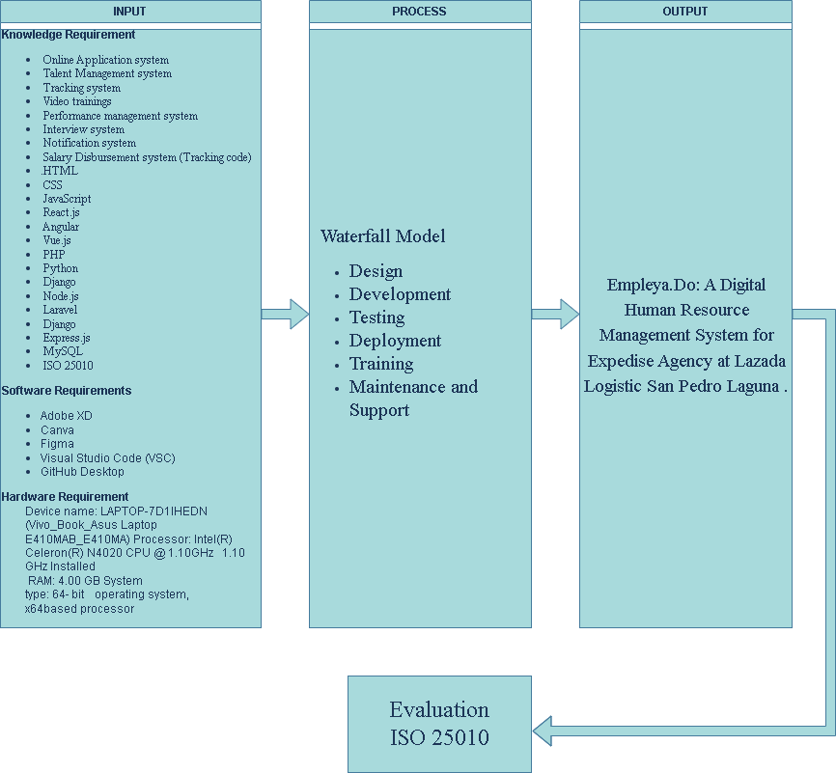

**Figure 22**. ISO25010 Software product quality

Source https://tinyurl.com/yc5e8t4a

**Input:**

The input section lists the knowledge and software requirements for the project. These include various web technologies, programming languages, design tools, and the hardware specifications of the device to be used for development.

Knowledge Requirement: Online Application system Talent Management system Tracking system Video trainings Performance management system Notification system Interview system Salary Disbursement system (Tracking code) HTML, CSS, JavaScript, React.js

Second, the Software Requirements that the researchers used are the following: Angular, Vue.js, PHP, Python, Django, Node.js, Laravel, Express.js, MySQL Adobe XD, Waterfall Model

Last are the Hardware Requirements used are the following: Device name: LAPTOP-7D1IHEDN (Vivo_Book_Asus Laptop E410MAB_E410MA) Processor: Intel(R) Celeron(R) N4020 CPU @1.10GHZ 1.10 GHz Installed RAM: 4.00 GB System type: 64-bit operating system, x64based processor.

**Process:**

The process section explains the development methodology, which is the Waterfall Model. The Waterfall Model is a linear sequential approach, where each phase of the development cycle is completed before moving to the next. This includes phases like:

Design: Conceptualizing the system architecture and functionalities. Development: Coding and building the system. Testing: Ensuring the system functions as intended and identifying and fixing any bugs. Deployment: Making the system available to users. Training: Providing instructions and guidance to users on how to use the system. Maintenance and Support: Ongoing upkeep and troubleshooting of the system.

**Output:**

The output section describes the final product of the development process. It's a digital human resource management system designed specifically for Expedise Agency, a logistics company in San Pedro Laguna. The system includes features such as:

Employee management Time and attendance tracking Performance evaluation Salary and benefits management Training and development Recruitment and onboarding

**Evaluation:**

The final step involves evaluation using ISO 25010. This standard provides guidelines for software quality evaluation, ensuring that the system meets the required standards and user expectations. The evaluation process includes assessing the system's functionality, performance, compatibility, usability, maintainability, and portability.

**Operational Definition of Terms**

The following terms or Phrases are defined to better understand the study:

***Collaboration*** refers to the technique of facilitating collaboration amongst researchers, consisting of features consisting of task control equipment, model management, and real-time commenting, through an internet-primarily based device.

***Communication*** refers to the method of facilitating communique amongst researchers, contributors, and stakeholders via an internet-based gadget.

***Compliance with Regulations*** refers to the ability of web-based systems to meet regulatory requirements related to research data management, such as GDPR or HIPAA.

Data Collection refers back to the technique of gathering records from members, which includes surveys, questionnaires, or behavioral facts, through an internet-based system.

***Empleya.Do*** refers to a Digital Human Resource Management System that will be implemented in Expedise Agency, a logistics company in San Pedro Laguna.

***Enhanced Collaboration*** refers to the potential of web-primarily based systems to facilitate collaboration amongst researchers, improving verbal exchange and lowering the threat of misunderstandings.

***Human Resource Management Computer System*** refers to a system that aims to offer technical assistance for the carrier first-rate of organization human useful resource management commercial enterprise.

***Inclusive Talent Development*** refers back to the technique that makes a speciality of developing all personnel, no longer simply top or elite expertise, thereby lowering skills mismatched and improving ordinary organizational skills.

***Online Recruitment*** refers back to the practice of using era and particularly internet-based total methods for duties which contain locating, attracting, assessing, interviewing, and hiring new personnel.

***Participant engagement*** refers to the manner of enticing members inside the studies manner, which includes supplying feedback on the have a look at, asking questions, or presenting extra facts, through an internet-based totally system.

***Performance Management System*** refers to a system that measures, tracks development, and evaluates the effectiveness of worker performance.

**Scalability** refers to the ability of web-based systems to handle large amounts of data and increase in capacity as needed.

***Strategic Talent Management System***refers to an important situation for developing and keeping talent, which allows organizations or a corporation to compete successfully.

***Support and Maintenance*** refers to the level of technical support and maintenance provided by the web-based system's developers or vendors

***Web-Based System*** refers to a utility that is accessed through HTTP.

**REFERENCES**

A, E. T. J. (2021). Implementation of Decision Support Personnel Recruitment System for Laguna State Polytechnic University-San Pablo City Campus. https://papers.ssrn.com/sol3/papers.cfm?abstract_id=3934151

Abramowski, N. (2023). What is CSS? A Web Developer's Guide for 2024. CareerFoundry. https://careerfoundry.com/en/blog/web-development/what-is-css/#why-is-css-important

Ahmed, A. M., Mohammed, C. N., & Ahmad, A. M. (2023). Web-based payroll management system: Design, implementation, and evaluation. SN Computer Science, 4(82). https://doi.org/10.1186/s43067-023-00082-5

Alexandrea, J. (2023). What is Bootstrap? Hostinger Tutorials. https://www.hostinger.ph/tutorials/what-is-bootstrap/

Anastasia, D. (2022). Why Use Angular for Web Development? Everything you Should Know About Angular Development Services. Cadabra Studio. https://cadabra.studio/why-use-angular-development-services-pros-cons/

Ap, B. (2021). What is Adobe Xd? How can I use it? - Bruno Ap - Medium. Medium. https://medium.com/@bascido/what-is-adobe-xd-how-can-i-use-it-a6c301dbb0c6

Awan, S. H., Habib, N., Akhtar, C. S., & Naveed, S. (2020). Effectiveness of performance management system for employee performance through engagement. SAGE Open, 10(4), 215824402096938. https://doi.org/10.1177/2158244020969383

Bakhur, N. (2024). What Is Node.js & Why To Use It For Web Development? neklo.com. https://neklo.com/blog/what-is-node-js#:~:text=js%20usage.-,Node.,%2Dtime%20event%2Dbased%20applications.

Bell, D. (2023). An introduction to the Unified Modeling Language. https://developer.ibm.com/articles/an-introduction-to-uml/?fbclid=IwZXh0bgNhZW0CMTAAAR1I0FaSgynN9xQG-yljMUiBLR2KaZ2hbee3vWHdXwpasxxieTmCmdVp3R4_aem_AcQHNzYelOVO3538duuPA_bVJOkm8atYkDSE5o241eqm2PP0EJ2Vl61HUZKfSxyBIOVBVxiVV3urp65t2U6ROt56

Britton, J. (2021). What is ISO 25010? Perforce Software. https://www.perforce.com/blog/qac/what-is-iso-25010#:~:text=the%20quality%20models.-,ISO%2025010%20Standard%20Overview,a%20particular%20context%20of%20use.

Bydrec, I. (2020). What is PHP Used for and It’s Importance to Web Development. https://blog.bydrec.com/what-is-php-used-for

Chen, S., Lee, A. Y., & Ahlstrom, D. (2019). Strategic talent management systems and employee behaviors: the mediating effect of calling. Asia Pacific Journal of Human Resources, 59(1), 84–108. https://doi.org/10.1111/1744-7941.12229

Chen, S., Thaduri, U. R., & Ballamudi, V. K. R. (2019). Front-End Development in React: An Overview. Engineering International, 7(2), 117-126.https://www.researchgate.net/publication/374154236_Front-End_Development_in_React_An_Overview

Clark, H. (2024). Theproductmanager. https://theproductmanager.com/tools/best-web-design-software/

Deshpande, C. (2023). What is Angular?: Architecture, Features, and Advantages. Simplilearn.com. https://www.simplilearn.com/tutorials/angular-tutorial/what-is-angular#:~:text=Angular%20is%20an%20open%2Dsource,for%20developers%20to%20work%20with.

Dobrovolska, V. (2024). Building websites that work: The power of PHP & MySQL. Webxloo. https://webxloo.com/blog/building-the-web-the-pillars-of-web-development-with-php-and-mysql.html

Donev, I. (2020). What is PostgreSQL and How Is It Used in Web Hosting? Free Web Hosting With PHP, MySQL, Email Sending, No Ads | AwardSpace.com. https://www.awardspace.com/kb/what-is-postgresql/

Eseme, S. (2023). What is Express.js? Everything you should know. Kinsta®. https://kinsta.com/knowledgebase/what-is-express-js/

Fachrizal, M. R., Radliya, N. R., & Manik, A. (2019). Development of E-Recruitment as a decision support system for employee recruitment. IOP Conference Series. Materials Science and Engineering, 662(2), 022018. https://doi.org/10.1088/1757-899x/662/2/022018

Fernandes, J. (2023). An introduction to designing a website on Figma. Productive Shop. https://productiveshop.com/an-introduction-to-designing-a-website-on-figma/#wireframing-on-figma

G, D. (2024). What is MySQL and how does it work. Hostinger Tutorials. https://www.hostinger.ph/tutorials/what-is-mysql

Gaba, I. (2023). What is GitHub And How To Use It? Simplilearn.com. https://www.simplilearn.com/tutorials/git-tutorial/what-is-github#:~:text=GitHub%20is%20a%20platform%20for,%2C%20commits%2C%20and%20pull%20requests.

Gadhavi, M.-. (2024). Python for Web Development: An Ultimate Guide. Radixweb. https://radixweb.com/blog/python-for-web-development

Gareth (2023). Welford. https://welfordmedia.co.uk/blog/10-benefits-of-canva-upgrade-canva-pro

Ghosh, D. (2023). Express.js for Javascript developers - the Talent500 blog. The Talent500 Blog. https://talent500.co/blog/express-js-for-javascript-developers/#Advantages

Giaquinto, R. (2022). What is MySQL and Why Is It Important to Web Design? GreenGeeks Blog. https://www.greengeeks.com/blog/mysql-and-web-design/

Gilch, P. M., & Sieweke, J. (2020). Recruiting digital talent: The strategic role of recruitment in organisations’ digital transformation. German Journal of Human Resource Management, 35(1), 53–82. https://doi.org/10.1177/2397002220952734

Girardin, M. (2024). What is GitHub? Uses and getting started. Forage. https://www.theforage.com/blog/skills/what-is-github

Guilizzoni, P. (2024).What are wireframes and why are they used? | Wireframing Academy | Balsamiq. https://balsamiq.com/learn/articles/what-are-wireframes/?fbclid=IwZXh0bgNhZW0CMTAAAR030Lqw4JQWpBuSSgTC1s5j0aJM66eyIjswHuFmZy45_veo6M2STl3SaWE_aem_AfpnljwYM4nUXJ7XKlo2wdiLj5fNbQ4gicV_Eo_M5J7L_B5qnQXPsfzvvGnSLz2v2rP_G7yv_PUj539yafTxomYP

Haim, I. (2024). What Is CSS? and How to Use it in Web Design. Elementor. https://elementor.com/blog/what-is-css/

Hanak, A. (2023). What is a wireframe in web design? Digital Silk. https://www.digitalsilk.com/digital-trends/what-is-a-wireframe/?fbclid=IwZXh0bgNhZW0CMTAAAR0QlxtBPeyVlMtUDB_3eqI7oz_QTLh4GSWu2615KpnLMX6xoASUsf2IUBU_aem_AfrLo2C8RFFB63ASSt30a0xnPbPntmYoxJ2GINmqUvsTXy5eWbc1Lwm-xhSEsZVU8bvtk6DkOBRdGy1ePtv_t_Mi#:~:text=A%20wireframe%20is%20a%20basic,the%20paths%20between%20the%20pages

Hannah, J. (2024). What is a wireframe? Your best guide. CareerFoundry. https://careerfoundry.com/en/blog/ux-design/what-is-a-wireframe-guide/?fbclid=IwZXh0bgNhZW0CMTAAAR0zJMHXaYgRN7ILyK8LBy176ED8OfSaM6jc_DcKf6PBzlYDsR74OrRctIE_aem_AfooGhuhH-Jc0FBVdf8HaKFJHIGfXeMQwhyMvYWUE1Kyi-OE00XopZq5DEtbgnydrva-gY8MCTCmvwQV3jkmTgcN

Hayes, A. (2022). HyperText Markup Language (HTML): What it is and how it works. Investopedia. https://www.investopedia.com/terms/h/html.asp#toc-the-bottom-line

Hughes, J. (2023). 6 types of Canva Graphics you can create (FREE) to grow your business. Elegant Themes Blog. https://www.elegantthemes.com/blog/tips-tricks/canva-graphics-you-can-create-free#conclusion

Hutsulyak, O. (2024). Why use React for web development: 10 reasons to apply. Blog | TechMagic. https://www.techmagic.co/blog/why-we-use-react-js-in-the-development/

Jalli, A. (2022). What is Laravel? Built In. https://builtin.com/software-engineering-perspectives/laravel

Jayatilleke, B. G., Ranawaka, G. R., Wijesekera, C., & Kumarasinha, M. C. (2019). Development of mobile application through design-based research. AAOU Journal/AAOU Journal, 13(2), 145–168. https://doi.org/10.1108/aaouj-02-2018-0013

Jia, Q., Young, M., Xiao, Y., Cui, J., Liu, C., Rashid, P., & Gehringer, E. (2022). Insta-Reviewer: A Data-Driven approach for generating instant feedback on students’ project reports. https://eric.ed.gov/?id=ED624078

Juviler, J. (2024). What Is GitHub? (And What Is It Used For?). What Is GitHub? (and What Is It Used For?). https://blog.hubspot.com/website/what-is-github-used-for

Kaliannan, M., Darmalinggam, D., Dorasamy, M., & Abraham, M. (2023). Inclusive talent development as a key talent management approach: A systematic literature review. Human Resource Management Review, 33(1), 100926. https://doi.org/10.1016/j.hrmr.2022.100926

Katariya, L. (2023). What is Express.js? A Comprehensive Guide to Beginners. Mobile App & Software Development Company | Brilworks. https://www.brilworks.com/blog/what-is-express-js-comprehensive-guide-to-beginners/

Kaur, N. (2023). Introduction to Angular: a powerful framework for web development. https://www.linkedin.com/pulse/introduction-angular-powerful-framework-web-development-navpreet-kaur-eiecf/

Khalfe, A. (2023). A Comprehensive Guide to Building a Web Application with MongoDB - The Talent500 Blog. The Talent500 Blog. https://talent500.co/blog/a-comprehensive-guide-to-building-a-web-application-with-mongodb/

Khare, M. (2023). What is Node.Js and why you should use it. Kinsta®. https://kinsta.com/knowledgebase/what-is-node-js/

Kugell, A. (2024). Web App Development in 2024: A Comprehensive Guide - Trio. Trio. https://trio.dev/web-app-development/

Kumar, P. (2023). An ultimate guide to web development in Python | BrowserStack. BrowserStack. https://www.browserstack.com/guide/web-development-in-python-guide

Lazuardy, M. F. S., & Anggraini, D. (2022). Modern front end web architectures with react. js and next. js. Research Journal of Advanced Engineering and Science, 7(1), 132-141.http://irjaes.com/wp-content/uploads/2022/02/IRJAES-V7N1P162Y22.pdf

Lutkevich, B., & Courtemanche, M. (2023). GitHub. IT Operations. https://www.techtarget.com/searchitoperations/definition/GitHub

Lynch, L. (2022). Why Adobe XD Is Our Choice for Web Design and Prototyping. (n.d.). buildcreate.com. https://buildcreate.com/adobe-xd-web-design-prototyping/

Mahalias, I., & Mahalias, I. (2024). Is Django good for web development? PLANEKS. https://www.planeks.net/is-django-good-for-web-development/

Mahara, N. (2020). UML (Unified Modeling Language). https://www.linkedin.com/pulse/uml-unified-modeling-language-nirajan-mahara/

Martinez, P. (2023). https://mockitt.wondershare.com/figma/figma-wireframe.html

Minoza Joemar & Cebu Technological University. (2024). Performance management system of hospitality management department of Cebu Technological University campuses. Ho Chi Minh City Open University Journal of Science. https://journalofscience.ou.edu.vn/index.php/econ-en/article/view/2697

Mir, M. A. (2023). What are the advantages and disadvantages of using Visual Studio Code or Atom? Medium. <https://medium.com/@ssc.ahmed.926748/what-are-the-advantages-and-disadvantages-of-using-visual-studio-code-or-atom-d3132bf1af85>

Mishra, D. P., Rout, K. K., & Salkuti, S. R. (2021). Modern tools and current trends in web-development. Indonesian Journal of Electrical Engineering and Computer Science, 24(2), 978-985.https://www.academia.edu/download/93413536/15706.pdf

Mleke, M. N., & Dida, M. A. (2020). A web-based monitoring and evaluation system for government projects in Tanzania: the case of Ministry of Health. Engineering, Technology and Applied Science Research/Engineering, Technology and Applied Science Research, 10(4), 6109–6115. https://doi.org/10.48084/etasr.3435

Murali, M. (2023). What is Visual Studio? All You Need to Know. blog.hubspot.com. https://blog.hubspot.com/website/what-is-visual-studio

Nihar-Raval. (2023). What is Django and how does it works? Radixweb. https://radixweb.com/blog/what-is-django#What

Okoro, G. O. (2024). DIGITAL HUMAN RESOURCE PRACTICES AND EMPLOYEE DEVELOPMENT IN NIGERIAN BANKING SECTOR. https://www.bwjournal.org/index.php/bsjournal/article/view/1859

Oncioiu, I., Anton, E., Ifrim, A. M., & Mândricel, D. A. (2022). The influence of social networks on the digital recruitment of human resources: an empirical study in the tourism sector. Sustainability, 14(6), 3693. https://doi.org/10.3390/su14063693

Ouellette, A. (2023). What is Bootstrap? An Awesome Beginner's Guide. CareerFoundry. https://careerfoundry.com/en/blog/web-development/what-is-bootstrap-a-beginners-guide/#what-is-bootstrap

Pathinayake, Y. (2021). Online Recruitment Management System for SiLEX Solutions (Pvt) Ltd. https://dl.ucsc.cmb.ac.lk/jspui/handle/123456789/4405

Paul, C. (2024). The role of JavaScript in modern web development. https://www.linkedin.com/pulse/role-javascript-modern-web-development-charles-paul-udcbc/

Pedamkar, P. (2023). How to Build Web Applications using MongoDB. EDUCBA. https://www.educba.com/how-to-build-web-applications-using-mongodb/

Pitaliya, S. (2024). Beginners guide to Python for software development. Radixweb. https://radixweb.com/blog/python-for-software-development#Python

Quoy, L. (2024). Visual Studio vs Visual Studio Code: What’s the Key Difference? DistantJob - Remote Recruitment Agency. https://distantjob.com/blog/visual-studio-vs-visual-studio-code/

Rebes, p. (2024). Software Quality Standards—How and why we applied ISO 25010. https://www.monterail.com/blog/software-qa-standards-iso-25010/

S, A. (2023). What is HTML? Hypertext Markup Language Basics explained. Hostinger Tutorials.https://www.hostinger.ph/tutorials/what-is-html#Is_HTML_Easy_to_Learn

S, A. (2024). What is PHP: Understanding the scripting Language. Hostinger Tutorials. https://www.hostinger.ph/tutorials/what-is-php/#Why_Use_PHP

S, V. (2023). Harnessing the Power of PostgreSQL: A guide to building Dynamic websites. https://www.linkedin.com/pulse/harnessing-power-postgresql-guide-building-dynamic-websites-vikram-s-wwgsc/

Schwarz, L. (2024). What Is HTML? An Intro to HyperText Markup Language. (n.d.). https://www.netsuite.com/portal/resource/articles/data-warehouse/hypertext-markup-language-html.shtml

Senthil.k-Wp. (2024). The Benefits of Web-Based Systems for Business - Aezion. Aezion. https://www.aezion.com/blogs/the-benefits-of-web-based-systems-for-business/

Sheldon, R. (2023). Unified Modeling Language (UML). Software Quality. https://www.techtarget.com/searchsoftwarequality/definition/Unified-Modeling-Language?fbclid=IwZXh0bgNhZW0CMTAAAR2DQdBgUTvJm9GUW7Qb_cY9i_rDJCgqlEUDVOZh9Pk37twzc0cDYpkQtSk_aem_AcR-gUVaJHGfFmfHmtC10zBjwb445vKvNMY1Hw1KfKAWIiEJfyumLyfhBdtAvdxbcfWQKAYA1TxCSRnFalUrvWwA

Sima, V., Gheorghe, I. G., Subić, J., & Nancu, D. (2020). Influences of the Industry 4.0 Revolution on the human capital Development and Consumer Behavior: A Systematic review. Sustainability, 12(10), 4035. https://doi.org/10.3390/su12104035

Singh, U. (2024). Impact of Bootstrap in web development. GoDaddy Resources - India. https://www.godaddy.com/resources/in/web-pro-in/impact-of-bootstrap-in-web-development

Singla, L. (2024, April 26). What is PHP for Web Development and Why Should You Use It? Net Solutions. https://www.netsolutions.com/insights/what-is-php/

Smart Recruiting as a modern tool for HR hiring in the context of business informatization. (2021). IEEE Conference Publication | IEEE Xplore. https://ieeexplore.ieee.org/abstract/document/9548558

Smith, O. (2022). Django Web Development in Python. (n.d.). datacamp.com. https://www.datacamp.com/tutorial/web-development-django

Stickman, N. (2021). Build a Website Using the Laravel Framework.linode.com. https://www.linode.com/docs/guides/how-to-create-website-using-laravel/

Techliance. (2024). HOW LARAVEL WEB DEVELOPMENT CAN GROW BUSINESS? https://www.linkedin.com/pulse/how-laravel-web-development-can-grow-business-techliance-bhgmf/

Technologies, O. (2023). The advantages of Web-Based systems over traditional software. https://www.linkedin.com/pulse/advantages-web-based-systems-over-traditional-software-/

Thite, M. (2020). Digital human resource development: where are we? Where should we go and how do we go there? Human Resource Development International, 25(1), 87–103. https://doi.org/10.1080/13678868.2020.1842982

Vainieri, M., Noto, G., Ferre, F., & Rosella, L. C. (2020). A performance management system in healthcare for all seasons? International Journal of Environmental Research and Public Health/International Journal of Environmental Research and Public Health, 17(15), 5590. https://doi.org/10.3390/ijerph17155590

Voon, L. Q., & Cheong, J. Q. (2021, June 30). Talent Management Practices and Employee Engagement-A Study in Malaysian GLCs. https://oer.ums.edu.my/handle/oer_source_files/1507

Wang, T., Li, N., & Li, H. (2021b). Design and development of human resource management computer system for enterprise employees. PloS One, 16(12), e0261594. https://doi.org/10.1371/journal.pone.0261594

Wiblen, S., & Marler, J. H. (2021). Digitalised talent management and automated talent decisions: the implications for HR professionals. International Journal of Human Resource Management, 32(12), 2592–2621. https://doi.org/10.1080/09585192.2021.1886149

Williams, A. (2023, December 5). What is MongoDB? A simple 2023 guide for developers. CareerFoundry. https://careerfoundry.com/en/blog/web-development/what-is-mongodb/#what-is-mongodb

Writes, B. (2023, December 13). How to use Figma for web design? - Alpha Efficiency. Alpha Efficiency.TM. https://alphaefficiency.com/how-to-use-figma-for-web-design

Ye, S. (2024). Research on performance management of ground service staff in Xiamen Airlines. Theseus. https://www.theseus.fi/handle/10024/856094

Zhang, J., & Chen, Z. (2023). Exploring Human Resource Management Digital Transformation in the digital Age. Journal of the Knowledge Economy. https://doi.org/10.1007/s13132-023-01214-y

Zhou, J., & Cen, W. (2023). Design and Application Research of a Digital Human Resource Management Platform based on ChatGPT. centuryscipub.com. https://doi.org/10.53469/jtpss.2023.03(07).10